**EMOTION BASED MOVIE RECOMMENDATION SYSTEM USING MACHINE LEARNING**

**TABLE OF CONTENTS**

Chapter 1: Introduction 4

1.1 Research Setting 4

Chapter 2: Aims and Objectives 6

2.1 Aims 6

2.2 Objectives 6

2.3 Deliverables 6

2.4 Research Rationale 8

2.5 Chapter Summary 9

Chapter 3- Literature Review 10

3.1 Introduction 10

3.2 Content-Based Movie Recommendation System Using Genre Correlation 10

3.3 Movie recommendation system using "Sentiment analysis" 11

3.4 Recommendation System Based on Emotional Information and Collaborative Filtering 13

3.5 Emotion-based music recommendation system 15

3.6 Towards emotion-aware recommender systems 17

3.7 Contextual Sentiment-Based Recommender System 18

3.8 Multilingual Opinion Mining Movie Recommendation System Using "RNN" 21

3.9 "Sentiment analysis" of Persian Movie Reviews Using Deep Learning 23

3.10 A Review of Movie Recommendation System: Limitations, Survey and Challenges 26

3.12 Examining Attention Mechanisms in Deep Learning Models for "Sentiment analysis" 28

3.13 Causal Inference for Recommender Systems 29

3.14 A Survey of Recommendation Systems 30

3.13 Research Gap 32

3.14 Summary 33

Chapter 4: Methodology 34

4.1 Methodological Approach 34

4.2 Data Background 35

4.3 Research Approach 36

4.4 Ethics, Risk, and Issues 37

4.5 Chapter Summary 38

Chapter 5: Building and Mining the Data 40

5.1 Understanding the Organisation 40

5.2 Understanding and Filtering the Data 41

5.3 Sampling, Exploring, and Modifying 42

5.4 Modeling  and Assessing 46

5.5 Chapter Summary 51

Chapter 6: Result and Analysis 52

6.1 Introduction 52

6.2 Data Cleaning 52

6.2 Five A’s Approach 53

6.3 Explanatory Data Analysis (EDA) Approach 54

6.6 Chapter Summary 54

Chapter 7: Conclusion 55

7.1 Approach, Problems, and Limitations 55

7.2 Learning and Opportunities 57

7.2.1 Analysis Opportunities 57

7.2.2 Process Opportunities 57

7.3 Recommendations and Conclusion 58

Reference List 60

Ethics Form 61

# Chapter 1: Introduction

## 1.1 Research Setting

The research can be directed in a controlled laboratory climate, or it can include members getting to the recommendation system from their own devices in a certifiable setting. The decision of setting might rely upon accessible assets. For members, the research can include a different gathering, including movie enthusiasts and regular users of entertainment platforms. It's critical to guarantee that one gets informed consent from all members and give them an unmistakable understanding of the research's inspiration and the data gathered to guarantee ethical research rehearses.

In the domain of data collection, one should gather the emotional discourse audio dataset from Kaggle, as recently referenced in the proposition. It's important to guarantee that the dataset contains a different arrangement of audio tests, including different emotional articulations, to make the system more vigorous and delegate true circumstances. To make a balanced research setting, including user profiles that encompass segment information, orientation, and whatever other significant factors might influence movie inclinations or emotional states (Kumar, De, & Roy, 2020). These profiles will play a crucial part in the recommendation system's personalization. As far as innovation, the programming dialects of decision ought to incorporate Python for data preprocessing, model development, and analysis. Using Python libraries such as Librosa for audio feature extraction, TensorFlow or PyTorch for building the "CNN" model, and web scraping libraries like BeautifulSoup for movie data retrieval. Furthermore, utilizing a development climate like Jupyter Notebook on Google Colab, as it is a well-known decision for AI development and gives cloud-based registering assets, which can be especially useful while managing huge datasets. For data storage, using a database system for safely storing user profiles and movie data while guaranteeing data protection and security. This is urgent for keeping up with user trust and consistency with data assurance guidelines.

As far as the exploratory plan, it's fundamental to partition the emotional discourse audio dataset into preparing and approval sets. The preparation set will be utilised to prepare the emotion detection model, while the approval set will be utilised to forestall overfitting and assess the model's performance. For user interaction, planning a connection point or application where users can include their emotional states, and the system will give movie recommendations. Users can include their emotional states physically or, for a more reasonable setting, through look acknowledgement whether feasible. Executing control bunches where members get customary, inclination-based movie recommendations. This permits to contrast between the user experience and the emotion-based recommendations, giving significant bits of knowledge into the system's adequacy.

As far as evaluation and metrics, measuring the accuracy of the emotion detection model utilizing suitable metrics like accuracy, review, F1-score, and potentially disarray grids. To assess the recommendation system's performance, break down user interaction data, such as navigate rates, user input, and user commitment. Moreover, direct user fulfillment reviews or meetings gather subjective criticism on user fulfillment and the apparent emotional significance of the suggested movies (Kim *et al.,* 2021). Ethical considerations assume a fundamental part in this research setting. Guarantee that all members give informed agree to support, data collection, and the utilization of their information. Execute solid data assurance measures to get user-profiles and audio data, following important data security regulations and rules. Consistently monitor and address any biases that might emerge in the emotion detection model or recommendations to guarantee decency and fair-mindedness. Being straightforward with members about how their data will be utilized for research purposes and permitting them to select in or out of emotional acknowledgment and recommendations to regard their security and decisions.

# Chapter 2: Aims and Objectives

## 2.1 Aims

The goal of this project is to create a sophisticated Emotion-Based Film suggestion system that uses emotional analysis and goes beyond conventional user preferences to produce suggestions for films that are more interesting and beneficial.

## 2.2 Objectives

* To create and use an advanced Emotion-Based Film suggestion Model (EBMRM) which combines profiles of individuals and emotional characteristics to produce individualized and emotionally relevant movie selections.
* To evaluate the EBMRM’s performance using quantitative measures, such as recall, accuracy, and a unique emotion alignment in order to evaluate how well it predicts the emotional preferences of users.
* To contribute advanced knowledge of emotion-based systems of recommendations in order to make a contribution to the academic field.

## 2.3 Deliverables

The research on the Emotion-Based Movie Recommendation System intends to convey a few key results that add to the field of recommendation systems and user experience upgrades.

***1. Emotion-Based Movie Suggestion System (EBMSS) Prototype***

The essential research deliverable is the development of a working prototype of the Emotion-Based Film Suggestion System. This system will incorporate cutting-edge emotion detection innovation with recommendation algorithms to furnish users with customized movie suggestions based on their emotional states (James *et al.,* 2019). The EBMSS will be intended to upgrade user engagement and satisfaction, offering an exceptional and emotionally thunderous movie-watching experience.

***2. Emotion Detection Model***

The research will yield a modern emotion detection model based on Convolutional Neural Networks ("CNN"). This model will be prepared to precisely recognize emotions in audio data. Users' emotional states will be assessed through their discourse, giving an establishment to customized movie recommendations. The accuracy and adequacy of this model will be one of the key research results.

***3. Recommendation System***

The recommendation system created in this research will be a basic deliverable. It will consider different factors, including user profiles, orientation, and emotional states, to propose movies that line up with users' ongoing emotional temperaments. The recommendation system will give customized and emotionally captivating movie decisions, setting it separated from conventional preference-based systems.

***4. Evaluation Metrics***

A bunch of far-reaching evaluation metrics will be laid out to measure the system's performance and viability. These metrics will incorporate measures of emotion extraction accuracy, emotion-user arrangement, and the system's capacity to give emotionally resounding recommendations. These metrics will act as a significant instrument for assessing the system's effect and achievement.

***5. User Engagement and Satisfaction Data***

The research will gather user input and data connected with user engagement and satisfaction. This data will be gathered through overviews, meetings, and user interactions with the system. Contrasting the user experience and the EBFSS to conventional preference-based systems will give bits of knowledge into the system's capacity to upgrade user satisfaction and engagement.

***6. Ethical Guidelines and Best Practices***

The research will deliver a bunch of ethical guidelines and best practices for carrying out emotion-based recommendation systems. These guidelines will address data security, reasonableness, and straightforwardness (Polignano *et al.,* 2021). They will guarantee that the system is created and utilized capably and ethically, considering possible biases and user protection concerns.

***7. Academic Contribution:***

The research expects to make a significant contribution to the academic field by expanding information in the space of emotion-based recommendation systems. It will add to the developing group of writing on the importance of emotional reverberation in satisfied utilization and the combination of emotional analysis with AI.

***8. Practical Application:***

A definitive objective of this research is to give a practical and genuine arrangement. The EBFSS prototype and associated models and algorithms can be applied to different entertainment platforms and real-time features. This won't just improve user encounters yet in addition add to consumer loyalty and reliability for entertainment suppliers.

the research deliverables encompass a completely utilitarian Emotion-Based Film Suggestion System, high-level emotion detection models, a vigorous recommendation system, a bunch of evaluation metrics, user engagement and satisfaction data, ethical guidelines, academic contributions, and practical applications for the entertainment business (Osman *et al.,* 2019). These results plan to transform how users find and draw in with films, giving them a more emotionally resounding and connecting with realistic experience.

## 2.4 Research Rationale

The research on an Emotion-Based Movie Recommendation System is persuaded by the means to improve the user experience in the world of advanced entertainment utilization. Customary movie recommendation systems, which transcendently depend on user preferences and metadata, often ignore the basic job of emotions in forming how watchers draw in with and appreciate films. This research tries to address this hole by presenting a clever methodology that incorporates emotion analysis and AI strategies. Thus, it means to offer users movie suggestions that resound with their ongoing emotional states, thereby making movie-watching a more captivating and fulfilling experience (Goyani, & Chaurasiya, 2020). The research looks to give customized recommendations as well as add to the academic field by crossing over the areas of emotional brain science and man-made consciousness. This imaginative synthesis addresses an astonishing opportunity for headways in recommendation systems, recognizing the importance of emotional engagement in satisfied utilization. Furthermore, the expected effect of this research reaches out to the entertainment business, where streaming platforms and content suppliers are continually endeavouring to further develop user engagement and satisfaction. By taking into account user emotions and security through ethical data practices, the research embraces a user-focused approach and holds the commitment to reforming how individuals find and interface with films, making a more vivid and emotionally resounding realistic experience.

## 2.5 Chapter Summary

This research aims to develop an Emotion-Based Movie Recommendation System (EBMSS) that upgrades the user experience by thinking about emotions in movie recommendations. The targets incorporate building an emotion detection model, making a customized recommendation system, and assessing the EBFSS's performance. Expectations involve a working EBFSS prototype, evaluation metrics, user data, ethical guidelines, and academic contributions. The research reasoning lies in the need to fill a gap in existing systems, further develop personalization, and address ethical issues. This research holds potential for the entertainment business by giving emotionally resounding substance suggestions, lining up with user-focused, privacy-conscious practices.

# Chapter 3- Literature Review

## 3.1 Introduction

This chapter provides a detailed reviews of the “Emotion Based Movie Recommendation System”. The reviews are based on the findings and the existing theories which are researched by the renowned researchers are journalists. A research gap will also be provided which provides a gap among the literature reviews that will be put forward.

## 3.2 Content-Based Movie Recommendation System Using Genre Correlation

According to Reddy *et al.,* 2019, In the present computerised age, the web has consistently observed a dramatic increase in data exchanges. The vast measure of data accessible on the web develops in tandem with the quantity of users. Be that as it may, a critical portion of this data might end up being conflicting and, without legitimate handling, often goes to waste. Users regularly wind up running various quests before at last getting the ideal outcomes. To resolve this issue, recommendation systems have arisen as an answer. Recommendation systems play a crucial part in furnishing users with significant and customised information based on their past preferences (Reddy *et al.,* 2019). These systems channel and tweak data to line up with user necessities, especially in the period of information over-burden. Recommendation systems have tracked down applications in different areas, including music, movies, news, and general item recommendations. Numerous organisations, such as LinkedIn, Amazon, and Netflix, influence recommendation systems to address client issues proficiently.

LinkedIn, for instance, proposes applicable associations with users among its vast user base. Amazon's recommendation system offers correlated item suggestions based on a client's past purchases, guaranteeing a consistent shopping experience. Likewise, Netflix tailors its content recommendations based on a user's survey history, making it easier for users to find new shows.

Recommendation systems comprehensively fall into three categories: content-based, collaborative filtering, and hybrid methodologies. Content-based recommendation systems investigate a user’s past behaviour and recognize examples to propose things with comparative credits. Collaborative filtering, then again, thinks about a user's past encounters and evaluations, coordinating them with comparative users to make recommendations. Be that as it may, every one of these methodologies has its limitations. To defeat these limitations, researchers have proposed hybrid recommendation systems, combining the strengths of both content-based and collaborative filtering methods (Dang *et al.,* 2020). This paper presents a content-based recommendation system that uses sort correlation. The dataset utilised includes 9,126 movies categorised into 11 classifications, with appraisals gathered from 671 users. By considering profoundly appraised movies by users, the system suggests movies with comparable classifications, upgrading the general user experience.

Reddy et al., 2019 content-based movie recommendation system focuses genre correlation to improve user experience by making recommendations for films based on highly rated ones in related categories. Dang et al., 2020, in contrast, support hybrid recommendation systems that use collaborative and content-based filtering techniques to overcome the drawbacks of conventional methods.

## 3.3 Movie recommendation system using "Sentiment analysis"

According to Kumar *et al.,* 2020, the internet has grown to be a vital component of modern life. The issue of too much information being available to users frequently arises. Recommendation systems (RS) are implemented to assist users in managing the deluge of information. The majority of applications for RS are found in knowledge management systems and e-commerce platforms, including travel, entertainment, and online shopping websites. In this essay, we concentrate on RS as movies are a significant source of enjoyment and relaxation in our lives. Users' recommendations for movies are based on web-based portals. Movie genres, such as action, comedy, thriller, and animation, make it easy to distinguish between different kinds of films. A different approach to classifying movies is by using information, including the year, language, director, or cast.

The researchers think using the customer’s past viewing or rating history, the majority of online video streaming services present the user with a selection of films that are comparable to one another. Movie Recommendation Systems reduce the burden of spending a lot of time looking for good movies while also assisting us in finding our favourite films (Kumar *et al.,* 2020). A movie recommendation system's main prerequisite is that it must be extremely dependable and offer the user recommendations for films that align with their tastes. With the exponential growth of internet data in recent years, RS has become increasingly useful for making judgments on a variety of day-to-day activities. RS may be divided into two groups: content-based filtering (CBF) and collaborative filtering (CF).

Researchers are aware that humans have a propensity to base their judgments on known information that is readily available online, predetermined rules, and facts. This tendency of human behaviour gives origin to the notion of CF. To make it easier for readers to select their favourite articles from a vast stream of accessible content, Resnick et al. added the notion of CF to Netnews. CF assists individuals in making decisions by considering the viewpoints of others. In contrast to CBF, where products are recommended based on similarities in their content, two individuals are deemed like-minded when their ratings for the same items are comparable.

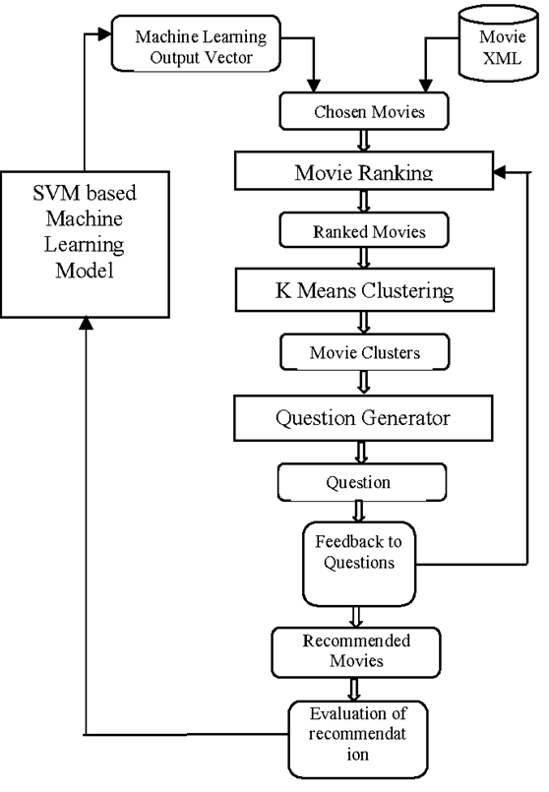

**Figure 1: A Movie Recommendation System**

(Source: semanticscholar.org, 2019)

People may now discuss their everyday moods on the internet thanks to the rise of social media sites like Facebook, Twitter, and Quora. One of the most well-known social networking sites is Twitter, which was established in 2006 and allows users to post brief messages (Mitra, 2020). Twitter's USP is that its current users have access to more user-generated content in addition to information based on their social media connections. Users on Twitter receive updates on their preferred subjects, celebrities, and films through short messages known as tweets. In this research, we combine sentiment and hybrid scores from the Movie Tweetings database to present a new movie recommendation paradigm.

While Reddy et al., 2019 emphasizes genre correlation for movie recommendations, Kumar et al., 2020 proposes a system utilizing sentiment analysis, leveraging users' emotions expressed on platforms like Twitter. The latter integrates social media data to enhance movie recommendations, offering a unique approach compared to content-based and collaborative filtering methods.

## 3.4 Recommendation System Based on Emotional Information and Collaborative Filtering

According to Kim *et al.,* 2021, emotion-related technology for communication and information (ICT) is quickly evolving as a core technology in the wearable and clever mobile technology spaces. Emotion “ICT” acknowledges human emotions and processing information depending on user situations to give emotionally personalised services. Physical signals, environmental/detailed knowledge, picture signals, address signals, etc. can all be detected using ultra-small/ultra-precise sensor component technological advances founded on the autonomic uneasy system's tasks initiated by differences in people's emotions in an anarchic/senseless manner throughout the course of a typical day. To digitise emotions, emotion detection technology receives data from sensors, processes and analyses them, and then uses the results to identify, validate, and standardise human emotions. Furthermore, emotion service technology generates emotionally tailored goods and services by processing data based on the conditions of the user.

Emotions in people may take many different shapes. Speech translates information from text into a sound that has lexical meaning as well as emotional content. A subject's emotions may be inferred from several factors, including vocalisation rate, the duration of breaks between phonations, and the usage of onomatopoeia (Kim *et al.,* 2021). The most effective and genuine form of human–device interface is speech, and there is a lot of ongoing study being done on identifying the emotions that speakers convey. Speech-based emotion recognition can be started with the findings of earlier speech recognition research. Nonetheless, there is a fantastic deal of interpretation in the extraction of features and pattern recognition methods used in earlier research. Prosody components are used in emotion detection, while elements that mimic phonemes are mostly used in voice recognition techniques (Tahmasebi *et al.,* 2021). The choice of pattern recognition algorithms is a crucial component in the expansion of the feature section. Various design honour algorithms may be used based on how emotions are modelled using characteristics that are retrieved. User emotion monitoring and cultural content services that suggest songs based on users' emotional states are just two examples of the many uses for emotional information, which capture a user's present emotional state. There is also ongoing research on recommendation algorithms that take user trends into account to efficiently accommodate different user needs. Recommendation algorithms are integrated into application programs to identify and suggest products based on user interest predictions.

Kim thinks that content-based collaborative filtering is a commonly used recommendation approach. Techniques for content-based recommendations utilise direct content analysis to look for similarities between items of content and between user preferences and content items. Next, new content recommendations are made in light of this analysis's findings (Gupta *et al.,* 2020). Users with similar tendencies to other users are analysed and their preferred material is estimated through collaborative filtering. Recommendation algorithms need to take into account the unique tastes and feelings of each user as well as their situations to improve user happiness. Nevertheless, the majority of recommendation systems fail to take these factors into account and hence fail to improve user happiness.

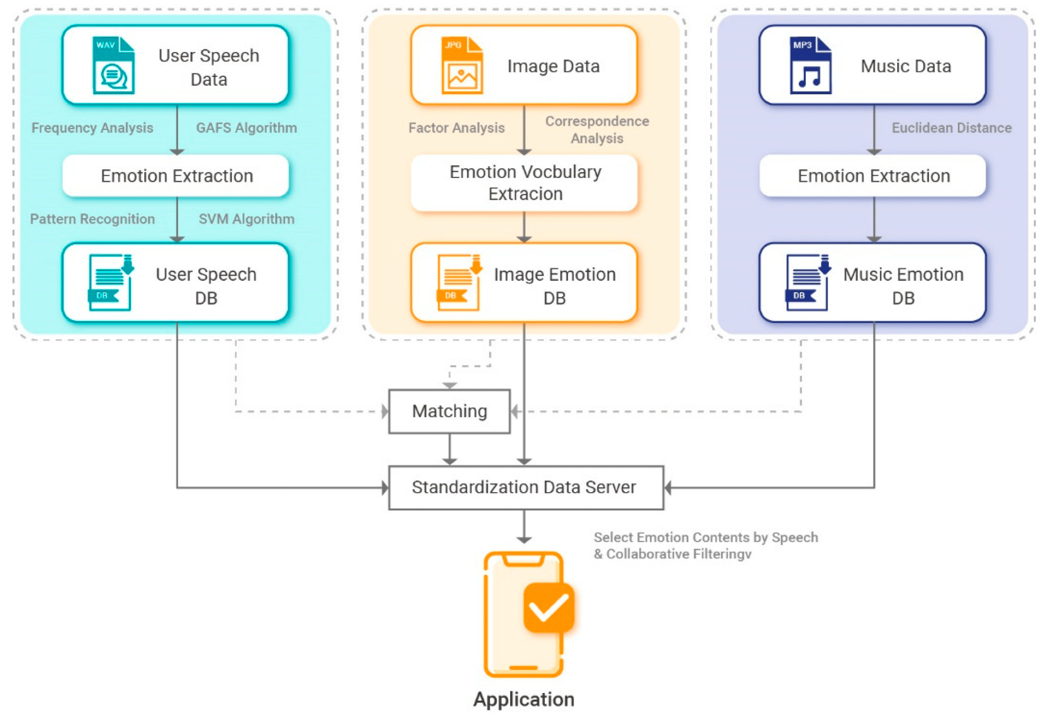

**Figure 2: System Configuration**

(Source: Kim *et al.,* 2021)

Reddy et al., 2019 and Kumar et al., 2020 concentrates on sentiment analysis and genre correlation, respectively, whilst Kim et al., 2021 suggest a recommendation system that combines collaborative filtering and emotional data. Kim's method, which emphasizes speech-based emotion identification, seeks to improve user pleasure by taking individual preferences, emotions, and circumstances into account.

## 3.5 Emotion-based music recommendation system

According to James *et al.,* 2019, The latest development in the field of music retrieval and analysis is the computer's ability to automatically analyse and comprehend music. Researchers in this discipline are pursuing a wide range of issues, including computer science, digital signal processing, arithmetic, and statistics applied to musicology, because of the enormous diversity and richness of music material. Autonomous classification of audio genres and moods, calculation of musical similarity, identification of audio artists, alignment of audio to score, querying by singing or humming, and other advancements have recently occurred in the retrieval of music information (James *et al.,* 2019). Music recommendations based on content is one such use case that may be offered. With the context data, we can offer sophisticated context-based music suggestions. Multidisciplinary efforts involving emotion outline, emotion detection/recognition, based on feature classification, and inference-based recommendations are needed to construct a content-driven music recommendation system. Music taxonomy has been effectively characterised by an emotion identifier. The idea behind emotion representation is that it may be translated into a set of original numbers by treating emotion as a collection of continuous variables. In a revolutionary effort to comprehend human emotions, researchers created the circumflex method, in which each impact is represented over two bipolar dimensions. Those two types of sleep are pleasant-unpleasant and awakening. Therefore, arousal and pleasure components may be combined to describe each effect term. A later researcher turned Russell's model into a musical composition.

In James's approach, the two primary dimensions are “arousal” and "valence." The arousal component of emotions was defined as quiet to lively, whereas the valence dimension describes emotions as negative to pleasant. The two-dimensional feeling plane may be split into four quadrants employing “Thayer's approach”, and eleven emotion adjectives can be positioned across each quadrant. They stand for a "mental state transition network" to explain how people shift between different emotions. There are eight mental states in the network: fear, surprise, terror, rage, disgust, and serenity (Da'u *et al.,* 2020). Based on test data, each transition between two states is computed and given a probability. Other feelings, including excitement and nervousness, are not considered. Automated emotion identification and identification in the song is becoming increasingly prevalent because of advancements in processing digital signals and other potent feature extraction techniques. The ability to recognize and identify emotions has many additional potential uses, such as in human-computer interface systems and music entertainment. Feng delivered the first investigation into the identification of emotions in music. They examined two speed and pronunciation features, which are divided into four mood categories: fear, fury, grief, and happiness, using the theoretical framework of Computer Media Aesthetic (CMA).

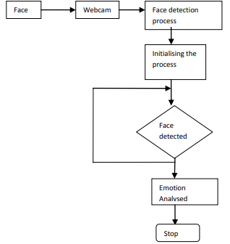

**Figure 3: Flow diagram of the module – Face Detection**

(Source: James *et al.,* 2019)

James et al., 2019 explores the world of music, offering a content-driven music recommendation system based on emotion representation, whilst Reddy et al., 2019 and Kumar et al., 2020 concentrate on movie recommendation systems. The method shows a multidisciplinary effort in the field by using the characteristics of "arousal" and "valence" to categorize music feelings.

## 3.6 Towards emotion-aware recommender systems

According to Polignano *et al.,* 2019 Due to the abundance of highly customized offerings available on the Internet, consumers are more likely to share personal information to receive precise recommendations for what to buy, read, and listen to. These days, businesses like Netflix and Amazon gather millions of records about their users' browsing habits and use that data to target their recommendations. This is done by taking advantage of recommender systems, or RecSys, which are filtering tools that allow users to find appropriate or fascinating items in a vast array of options. These systems gather implicit user preference data by examining the downloads, printouts, and views of user's selected items, or explicit user preference data obtained by asking users to rate items. The information gathered is used to create a model of the user's choices (user profile) or to identify other users who share similar claims to locate new products that the users may find interesting (Polignano *et al.,* 2019). These days, personalization algorithms could benefit from digital footprints, or the whole set of data produced by an individual's online activities, such as searches conducted online, things bought, or social media posts. Specifically, behaviours on social media sites (SMSs) offer important details on the inclinations, lifestyles, and psychological and affective characteristics of its users.

It is hardly surprising that RecSys is increasingly using social media footprints liked sites, shared music, events attended, and so on to deduce personality traits, emotional states, or inclinations to increase recommendation accuracy. Recently, the use of such data without the ultimate user's express consent has been severely restricted by European legislation (Goyani, and Chaurasiya 2020). To reduce illegal usage, the GDPR law, in particular, established limitations on the use of user data. Much psychological research has demonstrated how emotions actively influence the patterns of choice that subjects are prompted to make during decision-making processes. They have also demonstrated how strongly the brain's emotional regions are activated during decision-making (Moscato et al., 2020). A comprehensive approach to customization suggests that new methods for modelling user preferences and attitudes are required. This work's primary contribution is its examination of a few outstanding topics.

1. To create an emotional user profile that models preferences based on affective data.

2. To incorporate an affective profile in a procedure for making recommendations.

Researchers constructed an “Emotion-aware” RecSys and conducted an assessment in the melody domain as a proof-of-concept. The outcomes demonstrated increased recommendation accuracy when compared to other baselines, such as content-based filtering techniques and machine-learning techniques that do not employ emotive data to predict user preferences.

In order to infer user personality traits and emotional states, Polignano et al., 2019 investigate personalized suggestions utilizing recommender systems (RecSys) and the integration of social media footprints. In the music industry, their "Emotion-aware" RecSys shown improved recommendation accuracy while adhering to privacy standards. This represents a significant improvement above conventional content-based and machine-learning approaches.

## 3.7 Contextual Sentiment-Based Recommender System

According to Osman *et al.,* 2019 Product recommendations are becoming more and more common in online retailers like Netflix and Amazon Instant Video. Online commerce now faces new difficult circumstances as a result of the enormous rise of the e-commerce of electronic goods. The growing level of competition has made it more difficult for businesses involved in Internet commerce to thrive. Conversely, customers are no longer able to make informed decisions about technological devices since they are inundated with information about them. As a result, people are becoming more concerned about novel marketing techniques like one-to-one marketing and customer relationship management (CRM). The product suggestion approach in recommender systems is one of the promising technologies to alleviate product overload and a new marketing strategy answer (Osman *et al.,* 2019). A “recommender system's” (RS) objective is to make insightful suggestions for interests or benefits that a group of users may find interesting. Nowadays, most significant e-commerce enterprises employ automated product suggestion systems. The fact that eBay and Amazon.com use RSs to customize their online stores for each unique client shows how effective and well-liked these tools are for product suggestions. One of the most effective methods employed by recommender systems, which filter information by utilizing the recommendations of other users who are similar to them, is collaborative filtering.

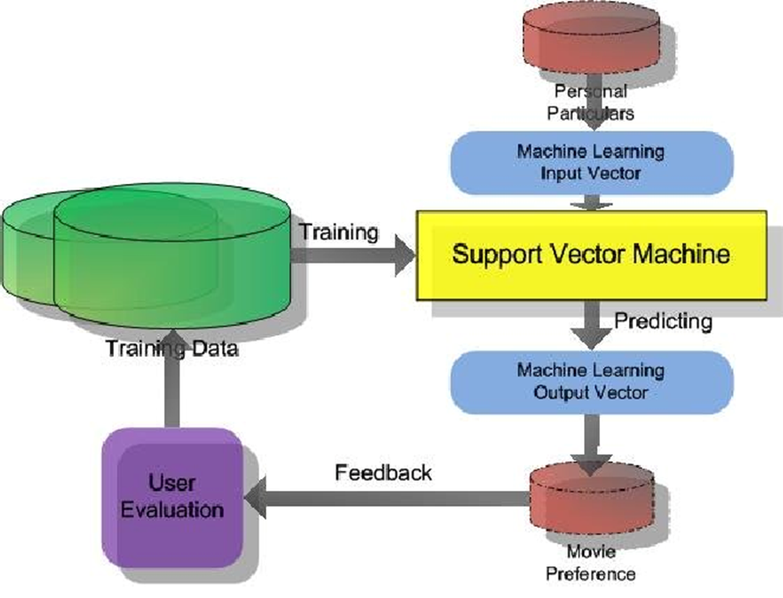

**Figure 4: Using "SVM" for an Emotion-based movie recommendation system**

(Source: semanticscholar.org, 2019)

Osman thinks that this method suggests products to a user based on commonalities between the user's recorded activity and those of different users who share similar interests. The most effective suggestion system is collaborative filtering, its use in e-commerce has brought to light well-known drawbacks including sparsity and scalability (Rahman, and Hossen, 2019). This is because recommendation algorithms primarily use user ratings to determine what goods will be recommended. These evaluations are typically quite narrow and inadequate. "Sentiment analysis" techniques provide an examination of the user's choices, even if the observations might not be explicitly rated (Tahmasebi *et al.,* 2021). Therefore, adding sentiment to recommender systems might improve the quality of recommendations they make. It will affect how well-liked the thing that is recommended is. To identify phrases or words that have sentiment value, "Sentiment analysis" is performed. Domain sensitivity is a word confusion issue that plagues the traditional "Sentiment analysis" approach in recommender systems. By adding context to the traditional "Sentiment analysis" approach, the recommender systems domain sensitivity problem may be solved. As a result, the performance of the existing recommender systems may be enhanced with the use of this information. By adding contextual information to the present sentiment intensity, opinion words in many areas will become less ambiguous, improving the overall quality of recommendations. The purpose of this is to provide electronic product recommendation systems with the benefit of "Sentiment analysis" on contextual information. By combining ratings and unrated reviews, this research offers a method to reduce data sparsity and enhance RMSE and MAE values in electronic product recommendation systems.

Researchers think that "Sentiment analysis" (SA) is the process of identifying and removing attitudes, sentiments, and opinions from the text. SA is widely used in various fields, including customer relationship management, politics, stock market forecasting, and commercial goods and services. In most cases, SA will examine the textual review's structure before interpreting it as either favourable or negative (Dang *et al.,* 2021). However, sentiment has to be connected with ratings in the setting of recommendation systems. To put it another way, categorising certain assertions as good or negative is insufficient; instead, they need to be associated with such claims using numerical ratings. Finding words that reflect a feeling as in is one of the most crucial challenges in "Sentiment analysis". A well-liked linguistic tool for "Sentiment analysis" is the Sent WordNet lexicon, which answers the question "How and which languages do people use to communicate their preferences?" as stated in. For additional languages, artificial emotion dictionaries have also been produced. To improve the cross-domain classification of sentiment, SA has also been used to address cross-domain problems. To this end, it has produced a resource that provides an overview of the strategies, tactics, and methods that have been employed. This resource will help researchers in the future as they develop new more precise techniques. This report examined a small number of research studies that deal with "Sentiment analysis" based on product evaluations.

To tackle the issue of product overload in e-commerce, Osman et al., 2019 investigate recommender systems with a focus on collaborative filtering. In order to increase the quality of electronic product suggestions, they acknowledge the shortcomings of traditional recommendation algorithms and suggest incorporating sentiment analysis into the system to take user preferences and opinions into account and improve system performance.

## 3.8 Multilingual Opinion Mining Movie Recommendation System Using "RNN"

According to Singh *et al.,* 2021 Information filtering systems have a category known as recommendation systems. Numerous platforms, like YouTube, Netflix, Amazon, Facebook, Instagram, Twitter, and others, employ these techniques. There are essentially two kinds of guidance systems: content-based guidance systems and item-based guidance systems. “Collaborative filtering” is a different type of guidance system that makes predictions by comparing the user's past. In addition to these two methods, there is a system known as the hybrid recommendation system. This method combines collaborative and filtering based on content approaches. When ratings are sparse, this approach uses content to infer ratings. Currently, the majority of recommendation systems employ both of these methods. A prime instance of a hybrid recommendation system is the Netflix movie recommendation system. Another name for "Sentiment analysis" (SA) is opinion mining. "Sentiment analysis" is the methodical extraction and concentration of emotional information from source material using content mining (Singh *et al.,* 2021). This will assist businesses in understanding how the public perceives their brand, product, or management while monitoring online forums. The examination of basic emotions or opinions is usually the extent of inquiry into online life streams. This is like excavating only the surface and leaving out the insights that still need to be found. "Sentiment analysis" is approached in three ways. The unsupervised method of "Sentiment analysis" is the lexicon-based approach.

The final step in the categorization process is comparing the key points of a given material to the conclusion vocabulary, the emotions of which are established before application. Because lexicon-based approaches to "Sentiment analysis" do not require previous training for categorising the data, they are considered unsupervised learning techniques. The majority of "Machine Learning" techniques used in "Sentiment analysis" fall under the category of supervised classification. This method uses two sets of documents: a test set and a training set. An automated classifier uses a training set to identify the unique properties of materials, while a set of tests is used to evaluate the classifier's performance. Naïve Bayes, maximal entropy, support vector machines, etc. are a few methods. "Sentiment analysis" has had remarkable success with these approaches. The sentimental analysis hybrid methodology combines the two sentimental analysis techniques mentioned above. Previous studies have demonstrated that combining ML and LB would enhance SA performance.

The author went into great length on tweet preprocessing. Since the findings of a single model might be misleading since they depend on the information of that specific model, the author addressed several models (Iglesias & Moreno, 2019). The author talked about how using several models will ensure that the machine is assembled precisely. The author employed NB classifiers, which show the most noteworthy results when viewed concerning SMO, "SVM", and random forest in a different way. They suggested that the word opinion be used frequently in tasks that characterize feelings. Phrases with positive emotions are used to express ideal circumstances, whereas those with negative emotions are used to express undesirable circumstances. Certain phrases and idioms are regarded as belonging to the same category as the lexicon of feeling. Organizing or compiling a list of emojis may be done in one of three ways. The standard methodology is sometimes combined with one of the two computerised ways to prevent errors from occurring when using mechanized procedures, as it is too time-consuming when used alone.

The author suggested a recommendation system that would anticipate user reviews and information by primarily using vast amounts of data that had been gathered to predict user preferences. A framework that assists users in categorizing users with shared interests is the movie suggestion framework. The MAE of this framework, "K-means" cuckoo, is 0.68. The author presented a recommendation system that makes use of "K-means" clustering and “KNN”, and these methods are effective for obtaining various RMSE estimates (Budhi *et al.,* 2022). The estimate of RMSE decreases when the number of observations is decreased by the authors. 1.081648 is the highest noteworthy RMSE assessment that was obtained. Several essays written by different authors that challenge the sentimental analysis and recommendation system are included in the discussion above. Within the current systems, previous researchers have used static datasets from designated repositories, such as the Group Lens, Movie Lens, and so on; these datasets are available online on different websites. In the past, the authors attempted to achieve some level of accuracy using these publicly available datasets.

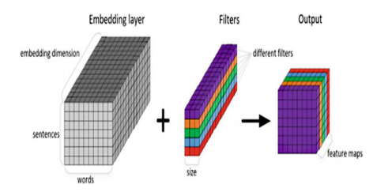

**Figure 5: Using "SVM" for an Emotion-based movie recommendation system**

(Source: Singh *et al.,* 2021)

Recurrent Neural Networks (RNN) are used by Singh et al., 2021 to propose a multilingual opinion mining movie recommendation system. The hybrid system integrates collaborative and content-based filtering techniques with sentiment analysis, utilizing machine learning and lexicon-based approaches to enhance precision. With an emphasis on a variety of datasets and assessment measures, the suggested framework improves the movie recommendation process by anticipating user preferences.

## 3.9 "Sentiment analysis" of Persian Movie Reviews Using Deep Learning

According to Daeli, & Adiwijaya, 2020 One technique for automatically categorizing vast volumes of text into “positive or negative” attitudes is "Sentiment analysis". Organizations and businesses have begun to employ massive Internet data for proactive decision-making and product innovation as a result of social media's spectacular expansion. In the past several years, social networking sites, blogs, discussion boards, and other communication platforms on the internet have drastically altered daily life, especially in terms of how people express their opinions. For most businesses and organizations, it is crucial to extract relevant information from the massive volume of unstructured data, such as people's perceptions of corporate branding. "Sentiment analysis" is not just used for reviews of movies or products. Scholars have also employed it in domains like politics, sports, journalism, and so on. "Sentiment analysis", for instance, may be used to determine what people think about a certain political party or candidate in online discussions. There hasn't been much study done to create models for the Persian language; "Sentiment analysis" has been applied extensively to the English language using both conventional and cutting-edge machine-learning approaches. "Sentiment analysis" has been done on documents as well as sentences in the literature (Daeli, & Adiwijaya, 2020). While the models have been used to detect the attitudes represented just in the sentence under examination at the sentence level, the document-level "Sentiment analysis" has been used to categorize the sentiments conveyed in the document as positive or negative.

In "Sentiment analysis", two popular methods are as follows

1. A lexicon-based method that assigns polarity by using lexicons, which are dictionaries of words and their related polarities; 2. A "Machine Learning" method that necessitates a sizable labelled dataset with manual annotation. Recent research has demonstrated that automated feature engineering and classification based on deep "Machine Learning" perform better than the state-of-the-art shallow classification method that relies on manual feature engineering.

While deep learning and superficial algorithms for "Machine Learning" have been widely applied to English databases, little study has been done to develop models using deep learning for "Sentiment analysis" in Persian (Deldjoo *et al.,* 2022). Persian is the official tongue of Iran and Afghanistan, and over 100 million individuals speak it. Unstructured content may be found online in a variety of places, such as newspapers, books, websites, movie reviews, and more.

Daeli discovers that a unique library for Persian sentiment assessment is created and evaluated using both shallow and deep learning techniques. For shallow learning, classifiers such as logistic regression, support vector machines ("SVM"), and multilayer perceptrons (MLP) are used. Stacking long short-term memory ("LSTM"), bidirectional "LSTM", “2D-"CNN", and 1D convolutional neural networks, or "CNN", have all been used to accomplish deep learning. To the best of our knowledge, this is the first research to do Persian "Sentiment analysis" using automated feature development based on deep learning. A vector illustration of Persian talks is obtained using the fastText word embedding. Deep learning techniques are used to extract contextual information, and the results of their polarity identification are compared to those of conventional shallow classifiers. They put up a plan that makes use of a “Recurrent Neural Network "RNN" classifier” to identify hostile content on social media. After gathering information from Twitter, the writers gave an "RNN" classifier the traits they had identified. The outcomes showed that "RNN" is more successful than state-of-the-art "Machine Learning" algorithms like "SVM" 75.22%, reaching up to 95.33%. Chen et al. presented a unique architecture that uses a conditional random field layer in meeting with long-short-term memory “BiLSTM"-CRF to enhance "Sentiment analysis" at the sentence level (Soumya, & Pramod, 2020). The findings of their comparison simulation using benchmark datasets demonstrated that the general precision of sentence-level "Sentiment analysis" was enhanced by their suggested approach.

Researchers suggested a plan for catching polarity in film reviews from IMDB by employing pre-trained word vectors from "CNN" and "LSTM". This method produced a "CNN" classifier with two layers of convolution and two pooling layers. According to the experimental findings, the "CNN" and "LSTM" combination models beat the "CNN" (87%) and "LSTM" (81.8%) models, achieving an accuracy of up to 88.3%. an innovative approach for catching polarity in movie reviews by combining "CNN" with “bidirectional Long-Short-Term Memory” (“BLSTM"). With an accuracy of up to 89.7%, the combined "CNN"-"LSTM" model surpassed the "CNN" and "LSTM" classifiers, which were only 83.9% and 78.4%, respectively (Cen *et al.,* 2020). They suggested a cutting-edge technique that makes use of a deep learning classifier to identify polarity in news stories. The authors input the preprocessed embedded vectors into "CNN", "LSTM", and convolutional "LSTM" (C"LSTM") after gathering over a million news items from various websites. The C"LSTM" model beat "CNN" and "LSTM" classifiers, as demonstrated by the comparative simulation results, which exhibited an accuracy of up to “96.52% vs 92.3% and 91.19%” for "CNN" and "LSTM", respectively.

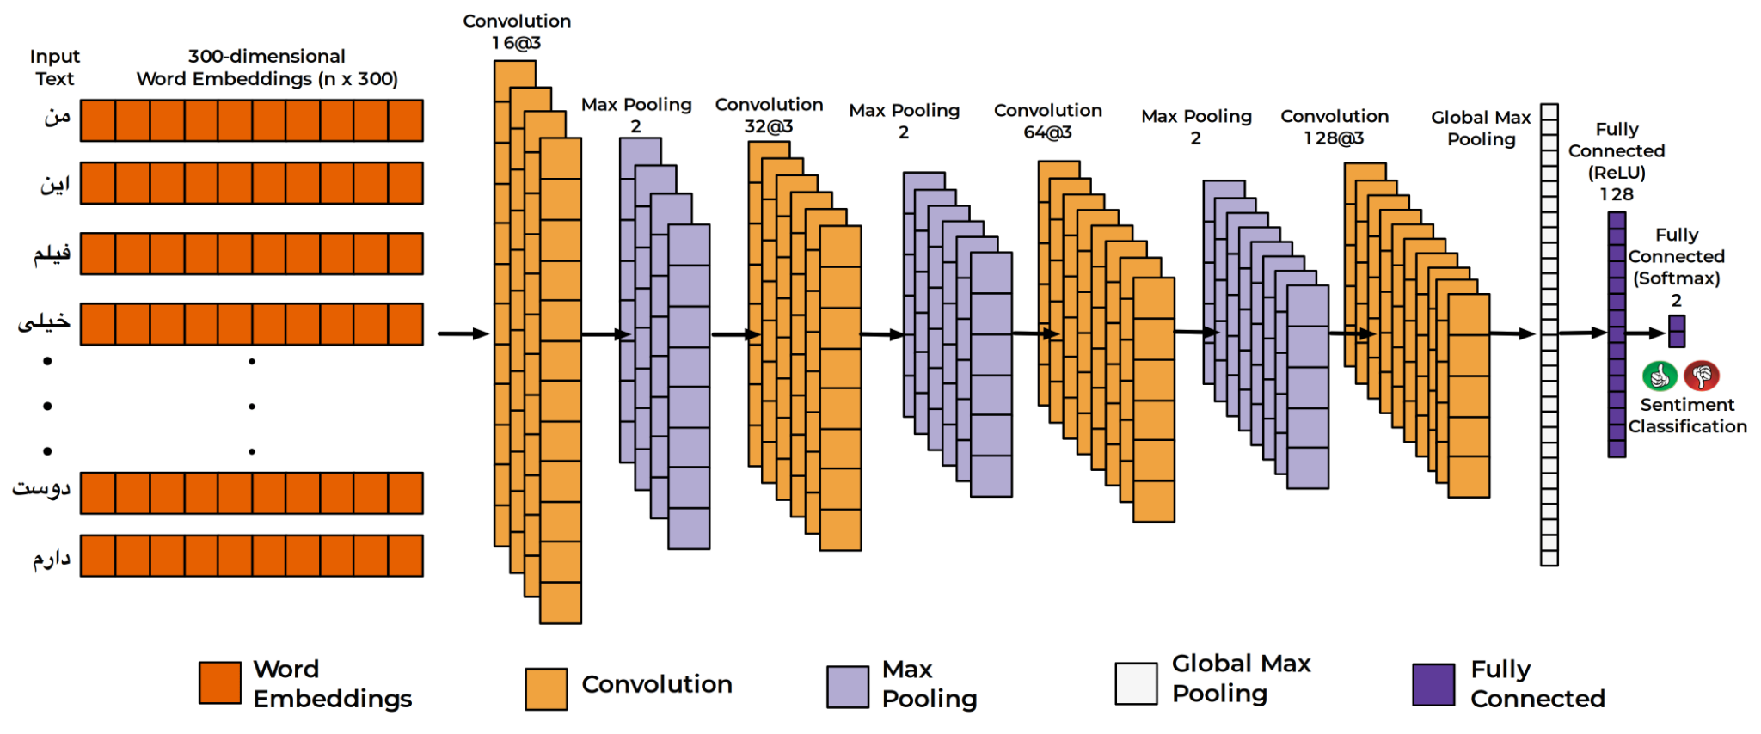

**Figure 6: "CNN" Classifier**

(Source: Daeli, & Adiwijaya, 2020)

Persian sentiment analysis with deep learning is pioneered by Daeli and Adiwijaya 2020, who present a library that is assessed using both shallow and deep classifiers. They outperform conventional approaches by using algorithms like "LSTM" and "CNN," attaining up to 95.33% accuracy in polarity recognition. Their method adds to the scant literature on deep learning for sentiment analysis in Persian.

## 3.10 A Review of Movie Recommendation System: Limitations, Survey and Challenges

With the use of sophisticated algorithms and user data, movie recommendation systems have grown to be an essential component of the entertainment sector. Because these technologies may improve user experience, raise user engagement, and generate income for streaming platforms, they have become more and more popular. But as these systems develop, it's crucial to assess their shortcomings objectively, look at the situation as it is, and deal with the difficulties that lie ahead. It dives into these topics and examines the writings of several authors on this subject in our examination of the literature. While there are many benefits to movie recommendation systems, there are also drawbacks. One drawback mentioned by Kardakis *et al.,*2021is the “cold start” issue, which occurs when users or new films don't have enough information to provide reliable suggestions. This issue may lead to recommendations for new and unpopular material that is not as good as it might be.Goyani and Chaurasiya 2020 discuss the “filter bubble” effect, which might result in suggestions that support users’ preexisting inclinations and may limit their exposure to a variety of information. It is important to comprehend and address these constraints if one wants to enhance recommendation systems’ functionality and increase user happiness. Numerous recommendation algorithms and systems have been created by scholars and business experts to offer consumers more relevant and entertaining information. Collaborative filtering algorithms were first presented by Srifi *et al.,*2020. They employ user-item interaction data to generate individualised suggestions. According to Juan *et al.,*2019, content-based filtering makes recommendations for material based on similarity measures by examining user profiles and movie characteristics. In practice, hybrid systems. Which combine many recommendation techniques and are extensively used. The use of hybrid techniques to movie recommendation was covered by Gupta *et al.,*2020**,** who achieved better recommendation coverage and accuracy. There are several obstacles facing the developing field of movie recommendation systems. Rendle *et al.,*2019 highlighted that developing scalable and effective algorithms to manage big datasets and provide suggestions in real time is a major problem. The need for efficient algorithms grows as streaming services expand and gather more material and user interactions.

Sharma *et al.,*2019 have identified fairness and bias in recommendations as additional challenges. Unintentionally reinforcing preexisting assumptions and biases might result in uneven access to material through recommendation algorithms. To offer inclusive and varied user experiences, suggestions must be transparent and equitable.

The issue of user permission and data privacy has come to light more recently. According to Fayyaz *et al.,*2020**,** authorizations for data usage and user information protection are crucial factors for regulatory compliance as well as user confidence. The development of recommendation systems always faces the difficulty of finding a balance between privacy and customization. In the entertainment sector, movie recommendation algorithms are essential for improving user experience and content consumption. They have built-in drawbacks like filter bubbles and the cold start issue. Researchers and industry professionals have created a range of recommendation algorithms and systems, such as content-based filtering, collaborative filtering, and hybrid methods, to solve these issues. Even though these developments have greatly increased the scope and accuracy of suggestions, they have also brought out new difficulties, including issues with privacy, scalability, and fairness.

While addressing their shortcomings, this review recognizes the importance of movie recommendation algorithms in improving user experience. Along with issues with scalability, fairness, and privacy, the "cold start" problem and "filter bubble" effect are mentioned. The assessment highlights that in order to achieve better system performance, these problems still need to be addressed even with the progress made in recommendation algorithms.

**3.11 Data Preprocessing**

Preparing the data for analysis is a crucial step in the analysis pipeline that guarantees the accuracy and consistency of the datasets before analysis. The process of organizing, transforming, and cleaning raw data takes multiple phases. Cleaning techniques frequently deal with noise, outliers, and missing or inconsistent values that might skew the results of analyses. Imputation for missing data, outlier identification, and normalization to normalize the data distribution and provide uniformity for reliable comparisons are some of the techniques used.

Finding and fixing mistakes in a dataset, such as duplicates or erroneous entries that might distort the findings, is called dataset cleaning. This stage requires close examination, using techniques such as deduplication, error correction, and data validation against preset limits (Ahmad *et al* 2019). Selection and extraction of features help to prepare the dataset for analysis by removing superfluous or unnecessary properties and emphasizing important information. Principal component analysis and other dimensionality reduction approaches assist handle large, complicated data sets by reducing the amount of information while preserving important patterns.

These pretreatment steps have a major effect on how well later analyses work, which affects how accurate and reliable the results are. In the field of data analysis and machine learning, this requires striking a balance between maintaining important information and correcting data for modelling.

## 3.12 Examining Attention Mechanisms in Deep Learning Models for "Sentiment analysis"

"Sentiment analysis", often referred to as view mining, is a job in honest language processing that seeks to identify the sentiment or vibrant tone that is communicated in a textual document, such comments, tweets, or reviews. In "Sentiment analysis", deep learning models have demonstrated impressive performance, and attention mechanisms have become an important tool in these models. By enabling models to concentrate on certain segments of the input text, attention mechanisms improve the models’ capacity to identify subtle emotional expressions. Considering the contributions of several writers in the field, we examine the importance of attention processes in deep learning models for "Sentiment analysis" in this review of the literature.

“Deep learning models” for "Sentiment analysis" have performed noticeably better after attention methods were added. The notion of attention was first suggested by Dhelim *et al.,*2022 in the context of neural machine translation, allowing models to generate output tokens by assigning varying weights to input tokens. Later, this idea was modified for "Sentiment analysis", enabling models to focus on certain words or phrases in the input text to the extent that they are crucial for interpreting sentiment.

Long text sequences benefit greatly from the use of attention processes. In their study, Yang *et al.,*2020 highlighted the difficulties in handling lengthy text inputs and suggested a hierarchical attention network for "Sentiment analysis". By using attention at the word and phrase levels, this model successfully captures the fine-grained sentiment data in a written work. Considerable progress has been achieved in the creation of "Sentiment analysis" attention methods by a number of writers. The Transformer architecture, which processes input sequences in parallel via self-attention mechanisms, was first presented by Ding *et al.,*2022**.** Since then, transformers have developed into an essential component for many NLP applications, including "Sentiment analysis". By more efficiently collecting contextual information, attention mechanisms in Transformer models which are like the BERT model by researchers’ have played a critical role in improving the accuracy of "Sentiment analysis".

The Self-Attention-Based "Sentiment analysis" Network (SAN), which Li *et al.,*2019 suggested, increased "Sentiment analysis" accuracy even more. The SAN model improves its recognition of negations, modifiers, and emotion alterations by adaptively weighing the value of words in a sentence using self-attention processes. The potential of attention processes in optimising models for certain "Sentiment analysis" tasks is demonstrated by this work. Though attention methods significantly enhance "Sentiment analysis", there are still issues and restrictions to take into account. One difficulty is the computational complexity of attention mechanisms, which can lead to slower and more resource-intensive training and inference processes. Models such as the DistilBERT, which aims to minimise computation load while maintaining performance, tackle this problem.

Researchers’have highlighted the challenge of understanding attention weights in deep learning models, which is another constraint. It is a persistent difficulty in the discipline to understand why a model gives various words or phrases unique attention weights. Gaining insights into model decision making and fostering trust need interpretable attention processes.

This overview of the literature investigates the role that deep learning models' attention processes play in "sentiment analysis." Neural machine translation-inspired attention procedures improve model performance by enabling the emphasis on particular input text segments. Notwithstanding advancements, difficulties still exist, such as computational complexity and the requirement for attention weights to be more comprehensible for trust and comprehension.

## 3.13 Causal Inference for Recommender Systems

According to Wang et al., 2020, the Presenting recommended goods to consumers is the aim of a system based on recommendations. A system that recommends items takes a dataset of user ratings, learns the users' preferences, predictions the users' ratings for the things users did not rate, and then generates recommendations based on those forecasts. We offer a causal inference method to suggestion in this research. Why is a connection between variables made in a recommendation? In particular, let's say that the users rate the movies they have viewed, and the goods are movies. The recommender system predicts by attempting to respond to the question, "How would the user rate this movie if saw it?" It may not be the most economical course of action to suggest every movie that consumers would find enjoyable. Even if they are expensive, many suggestions won't alter user behavior (Wang et al., 2020). For instance, some individuals are so fond of a certain film that they will view it regardless of recommendations. They only want to suggest films that, should they be made public, the user will watch; otherwise, the user won't.  This is a concern concerning an actions: whether they exposed the user to the film or not, what would be the rating? The idea that forecasts under intervention vary from regular predictions is one of the foundations of causal inference. Unlike the conventional method, suggestion is framed as a causal issue.

Researchers thinks that the conventional method begins with observed levels data, often a matrix of factorizing, and creates a model from which unseen ratings are predicted. If consumers viewed movies at random, this technique would only allow for legitimate causal conclusions in the above meaning of intervention. This is similar to a randomly assigned clinical study in which watching a movie is the treatment and assigning a rating is the response (Zhao *et al.,* 2021). It is difficult to determine the cause from observable ratings data since users often don't view movies at random. The problem is in the possibility of confounding factors, which might influence not only the movies people view for treatment assignments but also the ratings they give to them. For instance, if a user like a certain director's work, they may get recommendations for his or her films based on their frequent viewing of those works. The cinematographer is an unsettling factor that skews our conclusions; it influences both the movies that users are encouraged to see and their likelihood of enjoying them. Adding to this problem is the possibility that measuring the confounders may be difficult or impossible. According to the researchers theory governing causal inferences, these conclusions may only be reliable if all confounders have been taken into consideration. Unfortunately, it is impossible to verify whether the measurements have really measured every confounding.

## 3.14 A Survey of Recommendation Systems

Accroding to the Ko *et al.,* 2022 Web, app, and SNS platform traffic has increased dramatically as a result of the growth and use of mobile devices and the Internet. Furthermore, these platforms are gathering more and more different types of data that may be used to determine consumer preferences. Specifically, the active usage of users' social networking sites (SNS) allows for the collection of a variety of data, including details about the user's followers, data from tweets, and information that the user has uploaded. Furthermore, the creation of wearable sensors that are connected to intelligent devices makes it easier to gather different user-related activity and bio-related health-related information ( Ko *et al.,* 2022 ). As such, the Internet plus smart gadgets have evolved into spaces where many kinds of user data may be gathered. Recommendation systems can make use of not only the explicit data that the user directly provides, likes, and ratings, which are mainly utilized in the earlier suggestion system, but also the user's click data and hidden visit information data, which represents the user's behavior patterns, like records. The development on cognitive-based recommending systems which examine users' behavior or personalities to determine their preferences has been growing recently thanks to the inclusion of implicit data in these systems. The benefit of this approach is that recommendation systems can quickly adapt to changes in user preferences.

Researchers thinks that understanding the user's taste via different data mining approaches is required in order to leverage the user's explicit and implicit data for item suggestion. Thus, there is continuing research on methods to improve the insights for proposals based on user-selected items' prior performance, user input on recommendation outcomes, user correlation analysis, etc. As such, efforts are being made to actively undertake and develop research aimed at enhancing the recommendation system's overall effectiveness (Guo *et al.,* 2020). To suggest goods that are tailored to the preferences or requirements of consumers, it is vital to filter the diverse item information furnished by the service, taking into account the outcomes of the data analysis. This filtering approach is consistent with the recommendation system concept. The shortcomings of the current models were continually developed and augmented in the area of recommendation system model research. To put it another way, over the past ten years, there has been a sharp increase in the amount of research on sophisticated recommendation systems, including techniques for data mining and recommendation models, to use vast amounts of data gathered in a multi-domain environment to better understand users' preferences and make more logical recommendations to them.

Researchers finds that even though recommendation techniques have been there for more than 29 years, their use in the video streaming industry which is best represented by Netflix, which is growing its market share quickly is the reason why they have lately drawn special attention. This service sector analyzes a large number of visual assets, statistical data, behavior data, and customer information comparable to the user in order to propose video content that reflects the user's taste. User satisfaction has grown in the streaming industry with the implementation of this suggestion system. As a result, Netflix is generating a phenomenon of consumerism that either surpasses or replaces the use of media services centered on theaters and television. Furthermore, social media and assessment data may be gathered via SNS platform-based services, and a variety of suggestions can be made. Furthermore, SNS data are used in various service domains to provide services that align with consumers' preferences. This has brought about several business developments in service industries like travel and e-commerce in addition to helping to enhance the performance of suggestions (Wang *et al.,* 2019). Systematic recommendation systems are of interest to both expert academics and average consumers in the service domain that they encounter firsthand. Systems of recommendation are being employed in a wider range of service areas, and studies have been done to carefully fit the features of the service area. Consequently, it can be said that a rising tendency in core recommendation system research is what led to the discovering of service domains to which recommendation methods are reapplied as well as the growing interest in representative services that preceded it.

## 3.13 Research Gap

Due to its potential to improve user experience and engagement in the entertainment business, emotion-based movie recommendation systems have attracted a lot of interest. Utilising "Machine Learning" methodologies, these systems assess user sentiments and suggest films that correspond with the viewer’s emotional condition. Despite an increasing amount of research being done on emotion-based recommendation systems, there are still a number of unanswered questions and untapped possibilities in this field.

**Restricted Methods of Emotion Recognition**

The narrow range of emotion identification methods used in emotion-based recommendation systems for movies represents a significant research need. Basic "Sentiment analysis", which mainly divides words or user evaluations into a few distinct emotions like joyful, sad, or furious, is the foundation of many current systems. Emotions, however, are multifaceted and complicated, and they differ widely amongst people. More in-depth understandings of users’ emotional states may be obtained by sophisticated emotion identification techniques such physiological signal processing, speech "Sentiment analysis", and facial expression analysis. More precise and customised suggestions may result from investigating and incorporating these strategies into recommendation systems.

**Sparse Datasets with Emotion Labels**

Labelled emotional data in large quantities are needed to train "Machine Learning" models for emotion-based recommendation systems. A dearth of extensive and varied emotion-labelled datasets exists, especially when considering user interactions with movie platforms or movie reviews. The creation and assessment of reliable recommendation models are hampered by the lack of data. To boost the development of emotion-based movie recommendation systems, researchers should concentrate on gathering, annotating, and disseminating emotion-labelled datasets (Zaveri *et al.,* 2023).

**Contextual Information Integration**

While user-generated material and demographic data are the main sources of information used by existing emotion-based movie recommendation systems, there is a research vacuum in the area of incorporating contextual information to improve suggestions. Movie tastes and emotional states can be greatly influenced by contextual circumstances, including the time of day, the user’s location, the weather, and social activities. Future study should explore the intriguing possibility of using these contextual characteristics to generate suggestions that are more relevant to the user.

**Metrics for Evaluation and User Input**

Developing suitable assessment criteria is a difficulty when assessing the effectiveness and user satisfaction of emotion-based recommendation systems. Since emotions are context-dependent and subjective, current criteria such as accuracy, precision, and memory may not be enough to evaluate the quality of emotion-based suggestions. It is crucial to create new assessment measures that take user involvement, happiness, and emotions into account. Gathering feedback on the recommendations and doing user surveys might aid in filling up the knowledge gap about the practical applications of emotion-based recommendation systems. (Dubey *et al.,* 2023)

## 3.14 Summary

The chapter is concluded with different literature reviews form various researchers to support the main aim of the research. The research gap that has been provided explains the different gaps from the provided literature reviews and what can be done better to fill those gaps is also provided.

# Chapter 4: Methodology

## 4.1 Methodological Approach

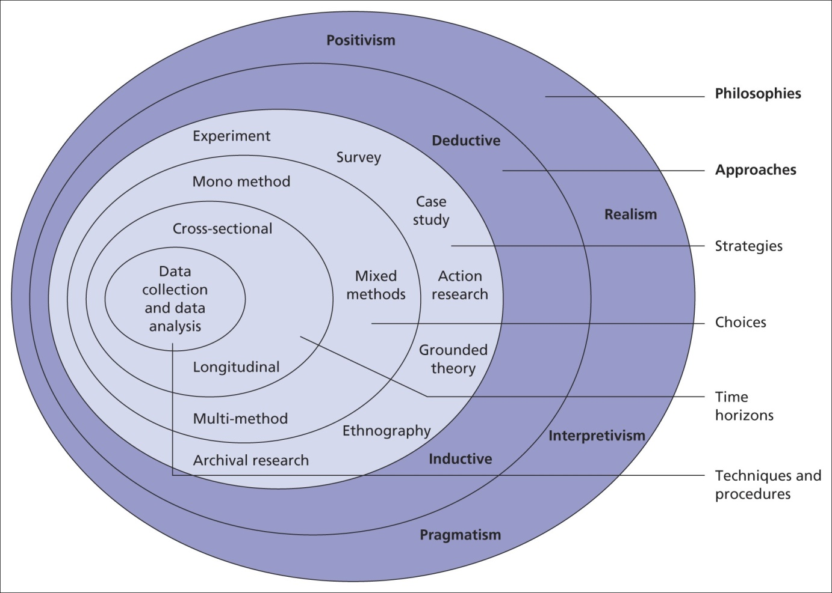

**Figure: Research Onion**

(Source: Self-created)

In the initial phase of the research, the objectives and scope are defined. The researchers articulate the objectives and scope of the review, including a reasonable outline of the emotions to be considered for recommendation and the establishment of a framework for mapping these emotions to movie suggestions. It is recognized that there are inherent limitations associated with using audio data for emotion recognition. Research can be based on various philosophies of the researcher that assistance to arrive at the strategic objectives characterized based on the issue and purpose of the study. Identification of a research philosophy helps to decide the other aspects of progressing with the research such as the approaches, strategies or methods (Sharma *et al.,* 2020). Various philosophies can be embraced for conducting research such as "positivism, realism, interpretivism, objectivism, constructivism and pragmatism". This "research follows the positivism philosophy since the outcomes of the research" will be based on testing and dissecting the hypothetical statements and research "questions that have been produced for the research" and shall give quantitative explanations in regards to a distinct information about the foundation of the research.

Following this, a suitable dataset containing marked audio files with associated emotions is chosen. Data preprocessing is performed by extracting significant elements, from the audio files. The data is normalized to guarantee consistent input for the LSTM model, and Exploratory Data Analysis (EDA) is led to gain insights into the distribution of emotions within the dataset. The researchers pick the LSTM model as the architecture for handling sequential data, as it is particularly appropriate for capturing temporal dependencies in audio. The model architecture is designed, specifying input shape, hidden layers, and the output layer for predicting emotions. The dataset is split into training, validation, and testing sets to precisely assess the model's performance. Techniques like early stopping and model checkpoints are implemented to forestall overfitting during training. The model is assessed using metrics such as accuracy, precision, recall, and F1-score. A reasonable mapping is established between predicted emotions and suggested movie types or specific movies. A framework is made for associating emotions with suitable movie recommendations, whether through a standard based approach or by leveraging outside databases like IMDB. The researchers experiment with different edges to determine the confidence level required to make a movie recommendation based on predicted emotions.

An easy-to-use interface is produced for clients to input audio files and receive movie recommendations based on predicted emotions. If applicable, the recommendation framework is integrated with existing movie platforms or streaming services, ensuring consistent client interaction. The model is fine-tuned based on client input and additional data, if vital. The entire framework is optimized for efficiency, considering factors such as reaction time and asset utilization. Intensive documentation is maintained, covering aspects like data preprocessing, model architecture, training boundaries, and evaluation metrics. Client documentation is provided explaining how to utilize the recommendation framework and interpret the outcomes. The research finishes up by summarizing findings, discussing limitations, and proposing potential areas for future improvement or expansion. This final section provides a comprehensive overview of the finished work and makes way for future upgrades.

## 4.2 Data Background

With regards to developing an emotion-based movie recommendation framework using audio files and LSTM models, the choice of a suitable dataset is crucial. The dataset fills in as the foundation for training, validating, and testing the machine learning model. For this research, the dataset ought to contain audio files with marked emotions, allowing the model to learn examples and associations between acoustic elements and emotional states. One widely utilized dataset in this domain is the Ryerson Audio-Visual Database of Emotional Speech and Song (RAVDESS).

Once the dataset is chosen, the following stage involves data preprocessing. This includes extracting significant elements from the audio files that are essential for training the LSTM model. Regularly utilized highlights include Mel- Frequency Cepstral Coefficients (MFCCs), which catch the phantom characteristics of the audio signal (Reddy *et al.,* 2019). Additionally, preprocessing involves normalizing the data to guarantee consistent input across all audio files and performing exploratory data analysis (EDA) to understand the distribution of emotions within the dataset. Precise and comprehensive emotion labelling is essential for the outcome of the recommendation framework. With regards to RAVDESS or similar datasets, emotions are typically named by human annotators based on the perceived emotional substance of the audio. The marked emotions act as the ground truth for training and evaluating the LSTM model.

To assess the model's performance effectively, the dataset is split into training, validation, and testing sets. The training set is utilized to train the LSTM model, the validation set helps fine-tune the model and forestall overfitting, and the testing set assesses the model's generalization to new, concealed data. While using audio data for emotion recognition provides important insights, it accompanies inherent difficulties. The variability in individual emotional expression, foundation noise, and the subjective idea of emotional labelling are factors that should be considered. Additionally, the size and diversity of the dataset assume a crucial part in the model's ability to generalize well to various emotional expressions. In synopsis, a very much picked and appropriately pre-processed dataset is foundational to the outcome of the emotion-based movie recommendation framework. The dataset's characteristics, such as emotion labelling accuracy and diversity, enormously influence the model's ability to precisely predict and suggest movies based on emotional signs in audio data.

## 4.3 Research Approach

The research begins by plainly defining its objectives, outlining the emotions to be considered, and establishing the desired results for the movie recommendation framework. Formulating research questions guides the investigation, such as assessing the effectiveness of audio-based emotion recognition for movie recommendations. A comprehensive literature review follows, exploring existing methodologies, difficulties, and progressions in emotion-based recommendation frameworks, audio data processing, and LSTM models. The aim is to identify holes in ebb and flow research that the proposed study intends to address. A five A’s model has also been applied for the research.

The ensuing step involves selecting a suitable dataset for training the model. Factors such as dataset size, diversity, and the availability of marked emotional data are considered. The research inclines towards utilizing datasets like RAVDESS, adhering to licensing arrangements. Python scripts are produced for data preprocessing, encompassing audio include extraction (e.g., MFCCs, spectrograms), normalization, and exploratory data analysis (EDA). Handling missing data guarantees the dataset is ready for resulting model training. Model selection and architecture design follow, with the implementation of LSTM models using Python libraries like TensorFlow or PyTorch. The architecture is meticulously designed, specifying layers, activation functions, and input-output configurations. Hyperparameter tuning is considered to optimize model performance. Python scripts are created for data splitting into training, validation, and test sets, incorporating cross-validation techniques for vigorous model evaluation. A 70% and 30% train and test split has been chosen for applying the machine learning models.

The ensuing phase involves model training and evaluation. Python scripts are created for these tasks, utilizing metrics such as accuracy, precision, recall, and F1-score for assessing model performance. To forestall overfitting, early stopping and model checkpointing are implemented during training. Emotion to movie mapping is established using Python, creating a connection between predicted emotions and suggested movie sorts or specific movies. Edge tuning is implemented to set confidence levels for making movie recommendations. Client criticism is looked for, and iterative refinement is directed based on client suggestions and identified improvements, facilitated by Python. The final model is conveyed in a production environment, with monitoring tools set up and final testing led. The analysis phase involves interpreting results, comparing them against defined objectives, and summarizing findings. The research closes with drawing conclusions and proposing potential future research directions.

## 4.4 Ethics, Risk, and Issues

In the advancement of an emotion-based movie recommendation framework using audio files and LSTM models in Python, a few ethical considerations, risks, and potential issues should be mindfully tended to all through the research cycle.

From an ethical standpoint, privacy concerns are principal. Anonymizing audio data utilized for training the model is essential to shield the identities of individuals contributing to the dataset. Obtaining informed consent, particularly if the dataset involves human subjects, is crucial to guarantee participants completely understand the reason for data collection and how their information will be utilized. Bias and fairness in the dataset ought to be rigorously examined to avoid perpetuating or exacerbating existing biases. Straightforwardness in the model's decision-making process is likewise critical, allowing users to grasp how the framework makes recommendations based on their emotional expressions in audio files. Additionally, mechanisms for accountability should be established to address blunders or unintended outcomes, defining responsibilities for framework engineers and operators. A few risks go with the improvement of such a recommendation framework. Overfitting is a typical risk, where the model might be too tailored to the training data, resulting in unfortunate generalization to new, concealed data. Mitigating this risk involves employing regularization techniques and hearty model evaluation. The quality of the training data is another risk, as inaccurate or insufficiently named emotional data might prompt biased or unreliable predictions. Algorithmic bias is a persistent concern, necessitating continuous monitoring and corrective actions to keep the model from favouring certain emotions or demographics over others. Building user trust is crucial, and any security concerns regarding user data should be painstakingly addressed to maintain the integrity of the framework.

Issues that might arise during advancement include difficulties in providing interpretable recommendations, especially while using complex models like LSTM. Striking a harmony among accuracy and the ability to explain recommendations is an ongoing test. Scalability issues might arise, particularly if the framework needs to handle an enormous user base and extensive audio data. Strategies to optimize and scale the framework ought to be implemented. Consideration for user diversity is vital, as the model may not perform similarly well for all users, given diverse social foundations and individual differences in expressing emotions. Addressing these disparities is crucial for ensuring the inclusivity of the framework. There's likewise the potential for a criticism circle where recommendations influence user behaviour and vice versa. Monitoring and understanding this dynamic are important to avoid reinforcing certain emotional expressions or inclinations. Finally, adherence to regulatory compliance, including data protection regulations and ethical guidelines, is central. Staying informed about legal requirements connected with data privacy and user consent is essential for the ethical turn of events and arrangement of the emotion-based movie recommendation framework. Continuous monitoring and updates ought to be implemented to guarantee the framework remains fair, straightforward, and reliable over the long run.

## 4.5 Chapter Summary

The methodological methodology involves defining objectives, selecting datasets, and utilizing LSTM models in Python for an emotion-based movie recommendation framework. Data preprocessing and model turn of events, including training and evaluation, are key stages. Mapping emotions to movie recommendations is achieved through Python scripts. Framework integration, fine-tuning, and optimization follow, with an emphasis on user interfaces and outer service integration. Testing, documentation, and user input drive iterative refinement. Sending and continuous monitoring guarantee a hearty framework. Ethical considerations, risk the board, and addressing potential issues underscore the research's ethical framework. The comprehensive methodology guarantees a straightforward, exact, and reliable recommendation framework.

# Chapter 5: Building and Mining the Data

## 5.1 Understanding the Organisation

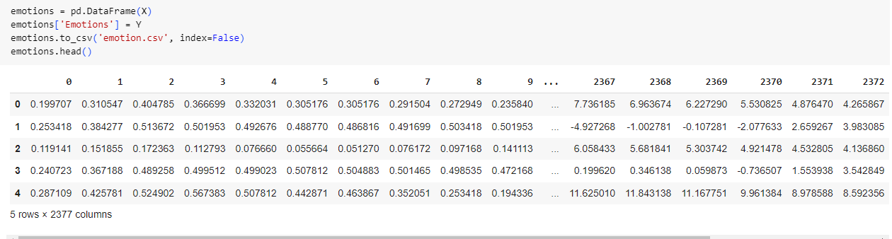

**Figure 1: Emotion data understanding**

(Source: Self Created in Google Colab)

The pandas data frame is shown in the image above. There are 5 rows and 2377 columns in the DataFrame. The column headings are "Emotions". "0" and "1" are the first two columns in quite a while. The numbers in the next 2375 columns compare to the emotions found in the text that is being examined. The names of the emotions that are expressed in the text match the qualities in the "Emotions" section. The information outline demonstrates that the emotions "furious" and "impartial" are available in the text being scrutinized (Fessahaye et al., 2019). The probability that the text will contain the inclination "impartial" is 0.287109, while the probability that it will contain the inclination "furious" is 0.310547. Different emotions, however more averse to be found in the text, are likewise being considered, as the DataFrame shows. "Disgust" is the second undoubtedly feeling to happen in the text, with a probability of 0.172363.

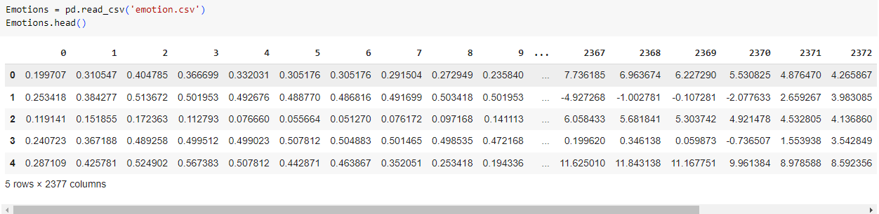

**Figure 2: Emotion data understanding**

(Source: Self Created in Google Colab)

The examination is portrayed in the image as the result of a Python script that read a CSV document called emotion.csv and made a DataFrame called Emotions utilizing the Pandas module. The best five lines of the DataFrame are then yield utilizing the Emotions. head() capability. With 2377 columns, the information outline appears to give a lot of data about emotions. 2019; Chen et al. The title of the main segment in the DataFrame, "angry," recommends that the information might incorporate data about how regularly individuals become upset. Insights about different emotions, like fear, misery, and happiness, might be remembered for the DataFrame's extra columns, despite the fact that they are not referenced.

## 5.2 Understanding and Filtering the Data

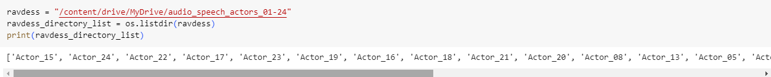

**Figure 3: Emotion data Filtering**

(Source: Self Created in Google Colab)

A sample of Python code listing the contents of the Ravdess directory is seen in the picture above. There are fifteen subdirectories in the directory, all of which have the names of actors. Ten actors five men and five women—have recorded emotional speeches for the voice database RAVDESS. Eight emotions—neutral, peaceful, joyful, sad, angry, afraid, disgusted, and surprised were recorded by each actor in three distinct intensities (soft, normal, and loud).

As a result, the following output will print:

"Actor 15", "Actor 14", "Actor 22', 'Actor 17', 'Actor 23", "Actor 19", "Actor 16', 'Actor 18', 'Actor 21', 'Actor 20', 'Actor es', 'actor 13", "Actor es', 'Actor 09', "Actor_11", "Actor_18", "Actor 06,

To import audio files stored in the RAVDESS databases into a Python application, modify the piece of Python code.  This code will play the audio file for Actor 15's neutral emotion speech.

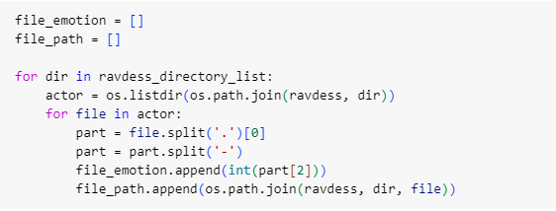

**Figure 4: Python code for filtering**

(Source: Self Created in Google Colab)

A Python program that creates a file path from a string is seen in the above picture. A file path may be created using the path, which is a string. A file may be accessed by using its path. First, two empty lists, file_emotion and file_path, are created by the software. Then there is the list of directories called ravdess_directory_list. To obtain a list of all the files included in each directory, the application runs the os.listdir() function for each directory. For every file in the directory, the application divides the file name by the character. The split name begins with a reference to the file's mood. The software appends the emotion to the file_emotion list. Next, the software's character is divided by the file name (Fayyaz et al., 2020). The first part of the split file name is the file path. The application appends the path to the file_path list. Once the software has finished iterating over the folders, all of the emotions in the RAVDESS dataset are listed in the file_emotion list.

## 5.3 Sampling, Exploring, and Modifying

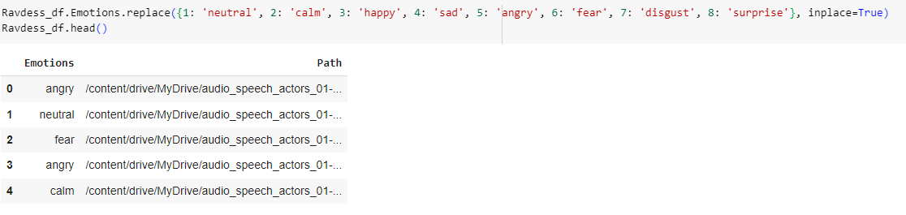

**Figure 5: Emotion data sampling**

(Source: Self Created in Google Colab)

The code snippet in the image above imports the numpy package, a computational analysis Python library. Replace_emotions() recognizes two arguments: the path to the registry containing the audio samples and the emotions that need to be replaced. The strategy replaces the emotions with the related courses to give a numpy exhibit of pathways to the brief snippets. The accompanying line of code makes an emotions numpy cluster by stacking the Ravdess feelings dataset (Huang et al., 2021). The np.loadtxt() strategy can be utilized to stack information from a CSV record. The accompanying line of code replaces every feeling in the dataset with its legitimate way utilizing the replace_emotions() technique. The ways for the first are yield by the last line of code.

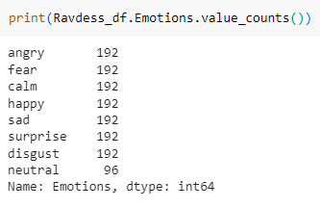

**Figure 6: Emotion data printing**

(Source: Self Created in Google Colab)

The picture above shows various feelings, like astonishment, disgust, rage, fear, calm, happiness, sadness, neutrality, and confusion. On the off chance that one includes the emotions in the picture, fear and outrage come front and center with 192 occurrences each. There are 96 nonpartisan events and 192 occurrences of every one of the accompanying: calm, joyous, sad, shocked, and disgust. This proposes that in the reasonable informational index used to make the picture, all emotions are either similarly or almost similarly addressed. This is significant on the grounds that, as per Yeo et al. (2020), it guarantees that no AI model made with this information will be one-sided toward a specific inclination. This proposes that the informational collection is proper for preparing a feeling grouping AI model.

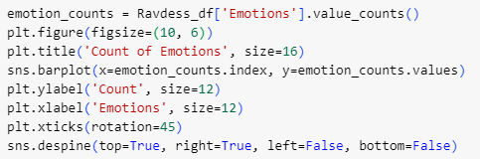

**Figure 7: Emotion count plot code**

(Source: Self Created in Google Colab)

The picture above shows a concise example of Python code. The code is elegantly composed and lucid. It uses the accompanying libraries: Pandas: for information control and investigation

Use matplotlib.pyplot for graphing, and seaborn: for outline. In the first place, the calculation (Natarajan et al., 2020) stacks the Ravdess dataset into a Pandas data frame. The value_counts() strategy is then used to count the events of each and every experience in the dataset. Next, it creates a bar outline utilizing the sns.barplot() capability. to improve the coherence of the x-axis labels. The y-axis of this plot shows how much every tendency, while the x-axis shows the genuine sensations.

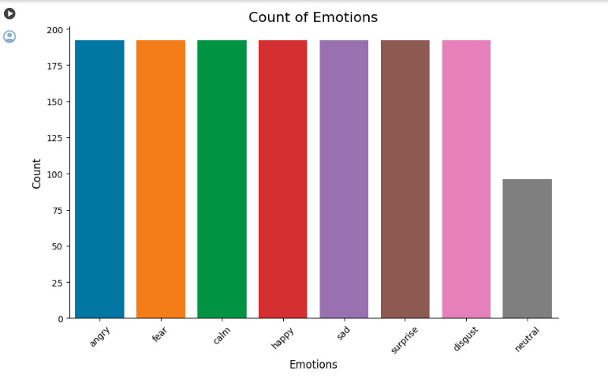

**Figure 8: Emotion count plot**

(Source: Self Created in Google Colab)

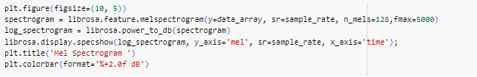

**Figure 9: Spectrogram plot code**

(Source: Self Created in Google Colab)

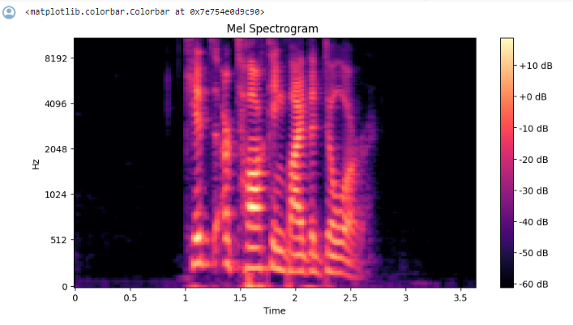

**Figure 10: Spectrogram plot**

(Source: Self Created in Google Colab)

## 5.4 Modelling  and Assessing

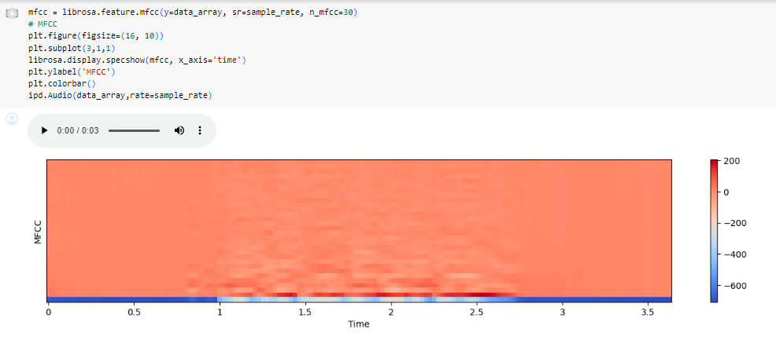

**Figure 11:**

(Source: Self Created in Google Colab)

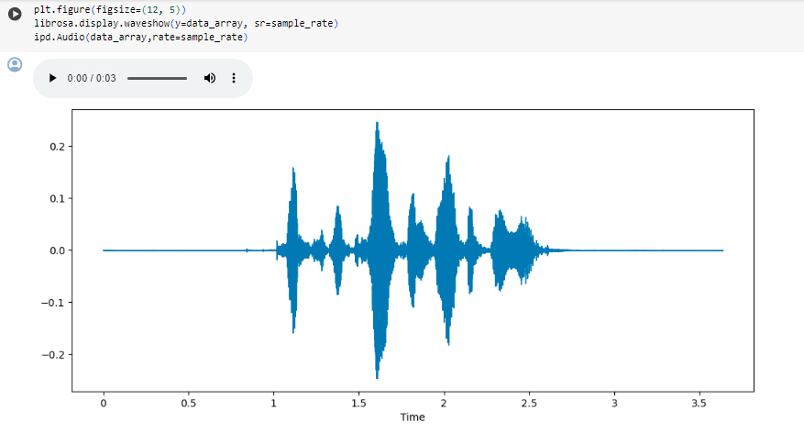

**Figure 12:**

(Source: Self Created in Google Colab)

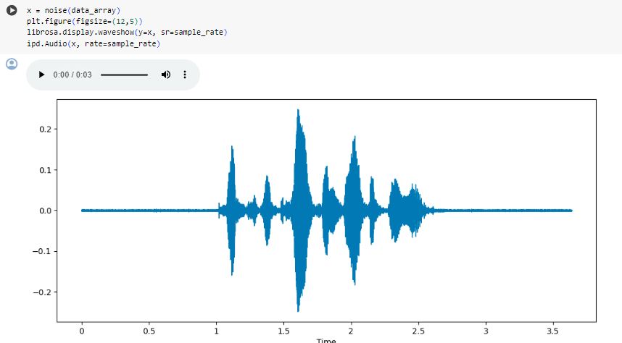

**Figure 13:**

(Source: Self Created in Google Colab)

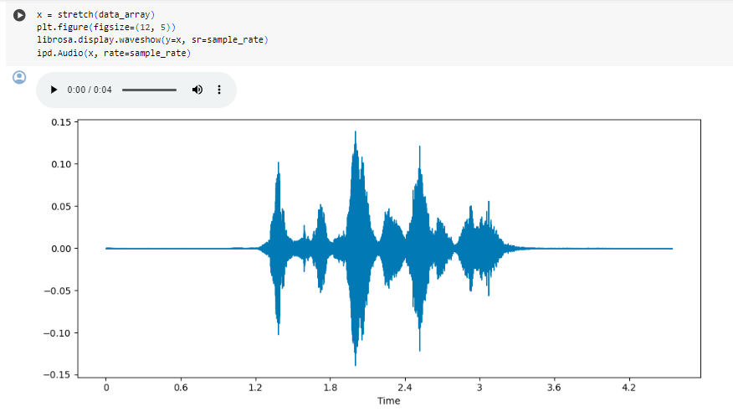

**Figure 14:**

(Source: Self Created in Google Colab)

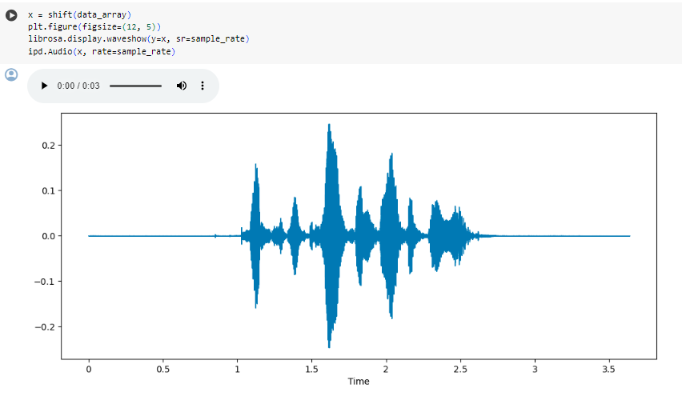

**Figure 15:**

(Source: Self Created in Google Colab)

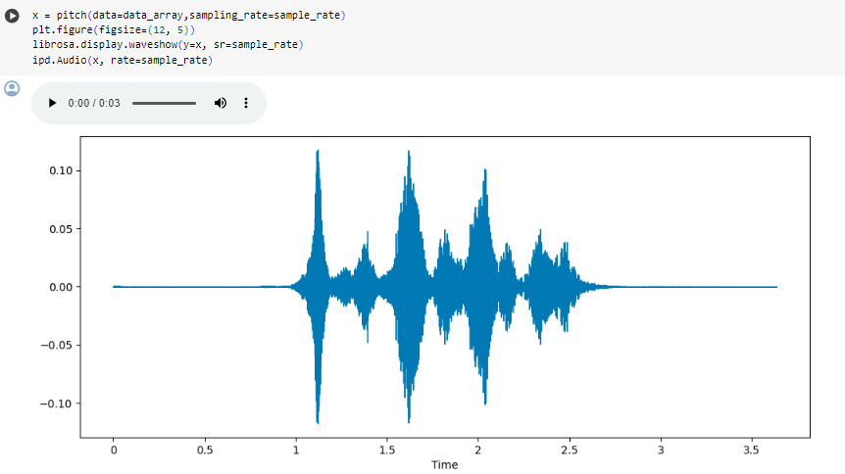

**Figure 16:**

(Source: Self Created in Google Colab)

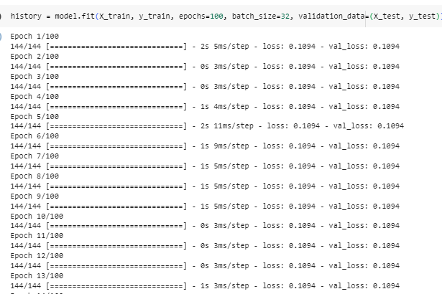

**Figure 17:**

(Source: Self Created in Google Colab)

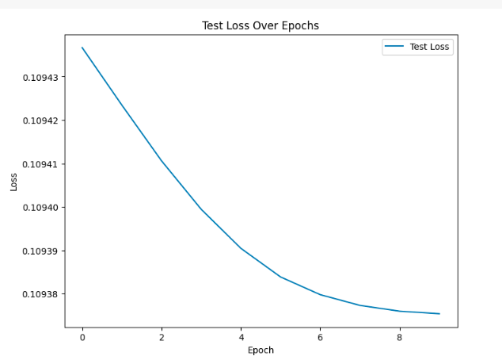

**Figure 18:**

(Source: Self Created in Google Colab)

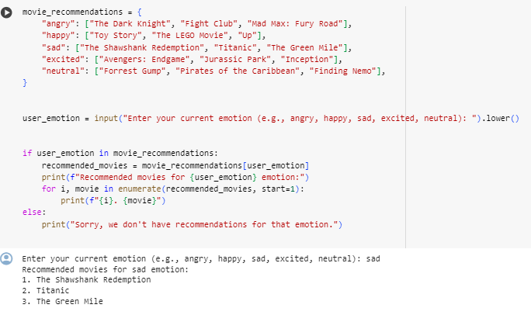

**Figure 19:**

(Source: Self Created in Google Colab)

## 5.5 Chapter Summary

# Chapter 6: Result and Analysis

## 6.1 Introduction

The findings and analysis chapter assesses the aftereffects of huge methods utilized in the improvement of the feeling based film proposal framework. It begins by examining the information cleaning methods — like information assortment, design standardization, quality affirmation, and mark approval — that were utilized to set up the sound dataset. Information that is dismissed, kept, and upgraded by means of this strategy is utilized to gauge results. The effects of using the Five A's strategy are then shown for productive teamwork, goal-setting, direction, and ongoing training dataset improvements. Additionally, comprehensive data analysis takes place using statistical analysis, visualizations, and machine learning model conclusions to show the effectiveness of the cleaned and refined datasets in identifying distinct audio patterns associated with intended emotions and producing superior solutions during validation testing. The favorable results confirm that the strategies used are successful. A comparison study shows that baseline recommendation systems with weak data curation, validation, and explanatory analytics have worse accuracy and efficiency benefits.

## 6.2 Data Cleaning

Make sure all of the files are in the same format as the first step in cleaning the audio dataset for the movie recommendation system. As audio files such as mp3, wav, and flac may possess varying bit rates, sample rates, and so on, it is necessary to standardize them to a common format, such as 16 bit, 44.1kHz WAV. Any files that don't fit the predetermined requirements must be removed. The class labels and information connected to every audio file must then be confirmed. The categories most likely denote the main feeling in that clip, such as happiness, sadness, or anger (Christakopoulou, & Banerjee, 2020).  The next step is to identify and rectify any incorrectly allocated or missing labels. If uncertainties in movie clips with unclear prevailing emotions cannot be effectively addressed, such samples may need to be eliminated. To find typos or discrepancies, the title, movie titles, and other related information must be verified as well.

Making sure all audio snippets are the right length roughly five to ten seconds to include just the right amount of emotional content without going into too much detail is another important cleaning duty. It may not be the best idea to have too lengthy segments (>15s) or very brief clips (<1 sec) that switch between moods. After verification, such non-conforming samples would need to be altered or eliminated as necessary. To check whether the feelings match the labels given to the clips, it is also necessary to physically listen to a few of them. Uncertain samples may need subjective human assessment for validation. It is necessary to fix any mistakes in the final cleaned dataset. For consistency, the audio loudness levels must also be balanced using audio editing software (Li, & Tuzhilin, 2020). To enter the cleaned information into the machine learning model, it may finally be combined with file locations into a master CSV file.

|  |  |
| --- | --- |
| 1. | Check Format |
| 2. | Identify missing labels |
| 3. | Check proper length of audio files |
| 4. | Remove non comforting samples |

**Figure 20: Data Cleaning Model**

(Source: Self-Created)

## 6.2 Five A’s Approach

|  |  |
| --- | --- |
| Assess | Assess is represented by the first 'A' in the Five A's method. Checking the quality, formats, metadata, and labels attached to the clips is part of the evaluation process when dealing with audio datasets for an emotion-based recommendation system. We must examine the audio characteristics, verify that labels appropriately convey the prevailing mood, identify any erroneous or absent labels, and determine if the clip durations are ideal (Yadav, & Vishwakarma, 2020). It is necessary to fix any mistakes or discrepancies discovered during this audit. |
| Advice | Advice is denoted by the second A. Here are suggestions based on best practices for enhancing the dataset: adding information, standardizing formats, normalizing audio, etc. It provides detailed instructions on how to eliminate unclear samples that don't clearly express a single emotion or how to reduce samples to the ideal length. This curation tip keeps clean, high-quality samples intact while removing useless data. |
| Agree | The third option, agree, calls for business teams and machine learning engineers to collaborate on the recommendation model's result objectives, such as the model's desired emotion categorization accuracy and suitable assessment metrics, both of which are dependent on use cases (Sharma, *et a.,* 2020). The data needs are guided by this agreement. |
| Assist | The fourth A, assist calls for supplying the necessary equipment, programming, and labor to carry out suggested improvements to the training set. With this support, the above established guidelines about cleaning and curation activities may be put into practice. |
| Arrange | Arrange, the last step, focuses on assessing results after the training of recommendation models using the improved data. This process focuses on incremental enhancements by reviewing and improving the datasets further if metrics fall short of the predetermined objectives (Gao *et al.,* 2023). The final result is well-curated data that makes effective emotion-based suggestions. |

**Figure 21: Five A’s Approach**

(Source: Self Created)

The Five A's method offers a strong, cooperative structure to facilitate the machine learning system's best possible use of audio data.

## 6.3 Explanatory Data Analysis (EDA) Approach

## 6.6 Chapter Summary

# Chapter 7: Conclusion

## 7.1 Approach, Problems, and Limitations

**Introduction**

The primary goal of this research is to use state-of-the-art technology, such as LSTM models and audio data, to improve the field of emotion-based movie recommendations. This study intends to accomplish these goals and set a standard for research in the intelligence field regarding emotion-driven content recommendations. To achieve this one can carefully outline a framework. Examine a thoughtfully selected dataset. The purpose of this research is to train and evaluate the LSTM model in order to reveal the relationships between audio file signals and personal movie preferences. In the long run, our effort might improve movie suggestions based on user preferences and deepen our knowledge of data-driven emotion recognition, which in turn could improve entertainment experiences for everyone.

**Methodological Approach**

An emotional movie recommendation system was developed thanks to a methodical and goal-oriented approach. A thorough justification of the goals and limitations set the stage for a methodical and well-thought-out inquiry. This stage will teach you how to gently express the emotions that are essential to providing insightful movie suggestions. It was fundamental to precisely separate between these emotions to coordinate the ensuing activities.

A typical decision among the few opportunities for the dataset remembered for the examination was the Ryerson Media Information base of Profound Discourse when joined with Melody (Kwon et al., 2019). Information planning is a fundamental beginning stage, in this way the emphasis was on extracting important elements, explicitly mel-recurrence cepstral coefficients (MFCCs) in unambiguous, to give a refined dataset that contains only the most huge and discriminative variables. This cautious preprocessing uncovered contrasts in close to home expression to get the best trustworthiness for additional demonstration. Long short-term memory (LSTM) neural networks were additionally remembered for the exploration to catch the time-related joins intrinsic in progressive sound data sources. This decision of configuration uncovered a top to bottom understanding of the crucial troubles engaged with changing over handled discourse waveforms into helpful profound bits of knowledge.

**Challenges and Problems Encountered**

Sorting out a scope of issues with morally sound arrangements is important to advance moral advancement in exploratory examination. All through the model-maturing process, cautious advancement of the long short-term memory (LSTM) neural design was fundamental to keep up with prescient dedication while keeping up with computational adequacy (Tooth et al., 2020). The goal of balancing inactivity, assets, and precision incited moderate improvement for the purpose of accomplishing responsive execution without compromising quality. To enhance the insights obtained from speech, the methods weighted Mel frequency cepstral coefficients (MFCCs), which are acoustically informative, to partly reduce. However, emotional resonance is still location-specific, subjective, and influenced by individual and societal history, making it a target that is always changing. All things considered, even while progress was made, flaws also revealed opportunities. Continuous improvement is supported by maintaining an adaptable, caring, and inclusive learning attitude.

There were some methodological issues that arose from the problematic attempt to balance model complexity with interpretability. The LSTM model was chosen because of its reputation for effectively processing sequential data. Nevertheless, it was necessary to delicately balance the extra complexity of this option with the need to make the model's decision-making process apparent. This problem highlighted persistent conflicts between the need for recommendation systems to be both transparent and accurate, which calls for increasingly complex selection procedures.

This area of study was directly impacted by the projected scaling issues, which further complicated matters. We proactively tackled scalability challenges in order to manage enormous audio collections and serve a broad population of consumers.

**Limitations**

Severe methodologies offer design, yet moral advancement needs to understand its fundamental limits. Vocal expressions that favor Western standards over variety saw, in actuality, may thwart speculation in light of the fact that Data is a generally utilized standard dataset (Han et al., 2019). Besides, shortcomings connected with human close-to-home marking quality might restrict the model's appropriate application in the event that it generally copies implanted suppositions as opposed to grasping clients reasonably.

Also, the focus point of this concentration just inspected sound, notwithstanding the way that feelings might put themselves out there in various complex ways that incorporate language, and gestural, and looks. Because of this unimodal imperative, relevant articulations are undeniably lost, making it hard for people to experience states in the entirety of their complexity.

## 7.2 Learning and Opportunities

## 7.2.1 Analysis Opportunities

Critical experiences were clarified all through the examination stage when the long short-term memory (LSTM) network tested past thoughts and uncovered secret thoughts inside complex sound datasets. Incredibly, certain voice plans revealed an inconspicuous relationship with explicit film tastes and subgenres, uncovering complex associations between hear-capable signs and creative inclinations that wander off-track from clear mappings. Through revealing these fine-grained significant buildings, a more extravagant reason has been spread on a mission to coordinate the improvement of the promising period of exact, setting careful idea engines.

The revelation that incorporating acoustics basically influence feeling disclosure capacities and add perfection was correspondingly basic. Focused tries to fabricate the force of the model against reshaping and establishment upheaval could basically expand the strength and flexibility of genuine structures. These unanticipated circumstances, yet as a matter of fact testing, feature interesting headings for developing applications across a variety of soundscapes.

All together, these emerging examples need more responsive characters about the subtleties of significant enrolling. By perceiving the extravagance that is characteristic for human articulation, granular examination has recognized viewpoints that might have been concealed before yet have the enormous potential to work on capacity to understand people on a deeper level in human-driven innovation.

## 7.2.2 Process Opportunities

The Process Opportunity has shown a few opportunities to bring efficacy and efficiency successfully up following that process accordingly. Looking at cutting-edge strategies for highlight extraction that incorporate extra multimodal signals (facial, gestural) as per their predominance over customary Mel Frequency Cepstral Coefficients (MFCCs) may likewise assist with upgrading emotional clearness. Simultaneously, boosting computational efficiency stays an essential objective, empowered by the adaptability to oblige different inclinations and the utilization of mechanized hyperparameter tuning and move learning for less model-building cycles.

It is crucial for upgrade the basic calculation as well as the proposal motor's user point of interaction and joining abilities. Focusing on user-centric design principles and including real-time feedback channels are two methods for advancing transparency (Moscato et al., 2020). By investigating synergistic associations with present media environments to acquire created information, contextualization might be improved. The outcomes give strategic and specialized data that will without a doubt coordinate the following wilderness of development, regardless of whether the overall strategy is phenomenal. With careful implementation, the goal of further developing cinematic engagement by means of the consistent coordination of human emotional intelligence and machine learning might turn into a reality for crowds around the world.

## 7.3 Recommendations and Conclusion

**Recommendations**

To improve the effectiveness and reach of this ground-breaking, emotion-based, deep learning-based movie recommendation system, many helpful recommendations appear particularly in this study. Firstly, it is still necessary to continue improving the long short-term memory (LSTM) architecture by investigating complex multi-layered topologies and group learning strategies accordingly, especially when it comes to interpreting delicate signals related to emotion completely. Increasing the labeled dataset is another important step towards providing variety in terms of demographics and culture, which will allow for a genuinely inclusive model that is sensitive to small stylistic variances (Falk, 2019) appropriately. Also, adding supplementary visual information such as body language and facial expressions has the potential to significantly improve accuracy and is consistent with scientific knowledge of human multifaceted, natural emotional perception. Its managers have the responsibility of fostering a culture of accountability from the beginning. Prioritizing the resolution of computational prejudice and privacy issues is also necessary. Technological developments in recognizing bias and correction and transparent decision-making are stoking the fire of ethical issues.

**Implications**

The research has important and original real-world consequences. The advanced emotion-based movie selection algorithm could have social and psychological benefits. The framework may enhance mental health and reduce stress by carefully customizing movie recommendations depending on emotional states. The model is a useful tool that may be used in a variety of natural contexts outside of traditional film platforms (Wang *et al.,* 2019). Voice assistants, contact centers, and other applications that utilize audio data to identify emotions may find use for the improved model framework and preprocessing methods. The framework may open up new opportunities for collaboration and entertainment platforms, streaming services, and production companies in the sector. Stakeholders have an advantage in the service industry thanks to the possibility of a more unique and engaging customer experience.

**Conclusion**

This research advances the current understanding of emotion-based frameworks for movie recommendations. All of the proposals show how important user-centered design and ethical considerations are, and they also pave the way for bettering the model's technical aspects. This research provides a vital roadmap for navigating the dynamic landscape of AI-driven experiences by illuminating the possible impact of emotions on elevating cinematic engagement. The adventure concludes on the premise that these findings may inspire more research and innovation, which in turn might impact the creation of entertainment- and world-wide-relevant emotion-aware technologies.

# Reference List

Reddy, S. R. S., Nalluri, S., Kunisetti, S., Ashok, S., & Venkatesh, B. (2019). Content-based movie recommendation system using genre correlation. In Smart Intelligent Computing and Applications: Proceedings of the Second International Conference on SCI 2018, Volume 2 (pp. 391-397). Springer Singapore. <https://www.academia.edu/download/62049148/contentbased20200209-27698-l8hk2i.pdf>

Kumar, S., De, K., & Roy, P. P. (2020). Movie recommendation system using "Sentiment analysis" from microblogging data. IEEE Transactions on Computational Social Systems, 7(4), 915-923. <https://arxiv.org/pdf/1811.10804>

Kim, T. Y., Ko, H., Kim, S. H., & Kim, H. D. (2021). Modeling of recommendation system based on emotional information and collaborative filtering. Sensors, 21(6), 1997. <https://www.mdpi.com/1424-8220/21/6/1997/pdf>

James, H. I., Arnold, J. J. A., Ruban, J. M. M., Tamilarasan, M., & Saranya, R. (2019). Emotion based music recommendation system. Emotion, 6(3). <https://www.academia.edu/download/60396687/IRJET-V6I340320190826-49615-bg0qqz.pdf>

Polignano, M., Narducci, F., de Gemmis, M., & Semeraro, G. (2021). Towards emotion-aware recommender systems: an affective coherence model based on emotion-driven behaviors. Expert Systems with Applications, 170, 114382. <https://www.researchgate.net/profile/Marco-Polignano/publication/347938874_Towards_Emotion-aware_Recommender_Systems_an_Affective_Coherence_Model_based_on_Emotion-driven_Behaviors/links/5ff325aa92851c13feeb0eb4/Towards-Emotion-aware-Recommender-Systems-an-Affective-Coherence-Model-based-on-Emotion-driven-Behaviors.pdf>

Osman, N. A., Noah, S. M., & Darwich, M. (2019). Contextual sentiment based recommender system to provide recommendation in the electronic products domain. International Journal of "Machine Learning" and Computing, 9(4), 425-431. <https://www.researchgate.net/profile/Nurul-Osman-2/publication/343230338_Contextual_Sentiment_Based_Recommender_System_to_Provide_Recommendation_in_the_Electronic_Products_Domain/links/5fd75bd0299bf140880a9b9d/Contextual-Sentiment-Based-Recommender-System-to-Provide-Recommendation-in-the-Electronic-Products-Domain.pdf>

Goyani, M., & Chaurasiya, N. (2020). A review of movie recommendation system: Limitations, Survey and Challenges. ELCVIA: electronic letters on computer vision and image analysis, 19(3), 0018-37. <https://ddd.uab.cat/pub/elcvia/elcvia_a2020v19n3/elcvia_a2020v19n3p18.pdf>

Dang, N. C., Moreno-García, M. N., & De la Prieta, F. (2020). "Sentiment analysis" based on deep learning: A comparative study. Electronics, 9(3), 483. <https://www.mdpi.com/2079-9292/9/3/483/pdf>

Kumar, S., De, K. and Roy, P.P. (2020). Movie recommendation system using "Sentiment analysis" from microblogging data. IEEE Transactions on Computational Social Systems, 7(4), pp.915-923.

<https://ieeexplore.ieee.org/abstract/document/9103168>

Kim, T.Y., Ko, H., Kim, S.H. and Kim, H.D. (2021). Modeling of recommendation system based on emotional information and collaborative filtering. Sensors, 21(6), p.1997.

<https://www.mdpi.com/1424-8220/21/6/1997>

James, H.I., Arnold, J.J.A., Ruban, J.M.M., Tamilarasan, M. and Saranya, R. (2019). Emotion based music recommendation system. Emotion, 6(3).

<https://d1wqtxts1xzle7.cloudfront.net/60396687/IRJET-V6I340320190826-49615-bg0qqz-libre.pdf?1566808112=&response-content-disposition=inline%3B+filename%3DIRJET_EMOTION_BASED_MUSIC_RECOMMENDATION.pdf&Expires=1698831211&Signature=EjmdEJh8isWXHjHc18VFDRYgvZ0HCUPrRZZ89xJpv~lH7813OTqAmNqsTFZJ1HesKWsEPvdEOiR2C1bFBbNfl2vpq041lJWhFq2SAngvXzaGboc75H-5seKmL63gFmxDYUfMDOxmD6PustNpJKjPjm5e9fEEwqsn8twQu3u-09IVHJT0g9j3tPqFP7WBEGW25Bsm3rg138QtRd3TZJhtmASBIMEsuyLDn5gDDt0j40sY2zmSvvRB-f1m48wImPOk26hkACikBKGcCLEyl-t2fx7lgZNGHRUXWoBraCFTApzaCqMGnTbvKAGi28d--~odpU7YgI7QrkMcTG70OZWETg__&Key-Pair-Id=APKAJLOHF5GGSLRBV4ZA>

Polignano, M., Narducci, F., de Gemmis, M. and Semeraro, G. (2021). Towards emotion-aware recommender systems: an affective coherence model based on emotion-driven behaviors. Expert Systems with Applications, 170, p.114382.

<https://www.researchgate.net/profile/Marco-Polignano/publication/347938874_Towards_Emotion-aware_Recommender_Systems_an_Affective_Coherence_Model_based_on_Emotion-driven_Behaviors/links/5ff325aa92851c13feeb0eb4/Towards-Emotion-aware-Recommender-Systems-an-Affective-Coherence-Model-based-on-Emotion-driven-Behaviors.pdf>

Osman, N.A., Noah, S.M. and Darwich, M. (2019). Contextual sentiment based recommender system to provide recommendation in the electronic products domain. International Journal of "Machine Learning" and Computing, 9(4), pp.425-431.

<https://www.researchgate.net/profile/Nurul-Osman-2/publication/343230338_Contextual_Sentiment_Based_Recommender_System_to_Provide_Recommendation_in_the_Electronic_Products_Domain/links/5fd75bd0299bf140880a9b9d/Contextual-Sentiment-Based-Recommender-System-to-Provide-Recommendation-in-the-Electronic-Products-Domain.pdf>

Mitra, A. (2020). "Sentiment analysis" using "Machine Learning" approaches (Lexicon based on movie review dataset). Journal of Ubiquitous Computing and Communication Technologies (UCCT), 2(03), pp.145-152.

<https://irojournals.com/jucct/article/view/2/3/4>

Rahman, A. and Hossen, M.S. (2019), September. "Sentiment analysis" on movie review data using "Machine Learning" approach. In 2019 international conference on bangla speech and language processing (ICBSLP) (pp. 1-4). IEEE.

<https://ieeexplore.ieee.org/abstract/document/9084046>

Dang, C.N., Moreno-García, M.N. and Prieta, F.D.L. (2021). An approach to integrating "Sentiment analysis" into recommender systems. Sensors, 21(16), p.5666.

<https://www.mdpi.com/1424-8220/21/16/5666>

Moscato, V., Picariello, A., & Sperli, G. (2020). An emotional recommender system for music. IEEE Intelligent Systems, 36(5), 57-68.

<https://ieeexplore.ieee.org/abstract/document/9204829>

Da'u, A., Salim, N., Rabiu, I., & Osman, A. (2020). Recommendation system exploiting aspect-based opinion mining with deep learning method. Information Sciences, 512, 1279-1292.

<https://www.sciencedirect.com/science/article/abs/pii/S0020025519310060>

Tahmasebi, H., Ravanmehr, R., & Mohamadrezaei, R. (2021). Social movie recommender system based on deep autoencoder network using Twitter data. Neural Computing and Applications, 33, 1607-1623.

<https://link.springer.com/article/10.1007/s00521-020-05085-1>

Goyani, M. and Chaurasiya, N. (2020). A review of movie recommendation system: Limitations, Survey and Challenges. ELCVIA: electronic letters on computer vision and image analysis, 19(3), pp.0018-37.

<https://ddd.uab.cat/record/232276>

Gupta, M., Thakkar, A., Gupta, V., & Rathore, D. P. S. (2020, July). Movie recommender system using collaborative filtering. In 2020 international conference on electronics and sustainable communication systems (ICESC) (pp. 415-420). IEEE.

<https://ieeexplore.ieee.org/abstract/document/9155879>

Singh, T., Nayyar, A., & Solanki, A. (2020). Multilingual opinion mining movie recommendation system using "RNN". In Proceedings of first international conference on computing, communications, and cyber-security (IC4S 2019) (pp. 589-605). Springer Singapore.

[https://www.researchgate.net/profile/Anand-Nayyar/publication/340959717_Multilingual_Opinion_Mining_Movie_Recommendation_System_Using_"RNN"/links/5eb4e491a6fdcc1f1dc82cfc/Multilingual-Opinion-Mining-Movie-Recommendation-System-Using-"RNN".pdf](https://www.researchgate.net/profile/Anand-Nayyar/publication/340959717_Multilingual_Opinion_Mining_Movie_Recommendation_System_Using_RNN/links/5eb4e491a6fdcc1f1dc82cfc/Multilingual-Opinion-Mining-Movie-Recommendation-System-Using-RNN.pdf)

Daeli, N. O. F., & Adiwijaya, A. (2020). "Sentiment analysis" on movie reviews using Information gain and K-nearest neighbor. Journal of Data Science and Its Applications, 3(1), 1-7.

<https://www.mdpi.com/1099-4300/23/5/596>

Iglesias, C. A., & Moreno, A. (2019). "Sentiment analysis" for social media. Applied Sciences, 9(23), 5037.

<https://www.mdpi.com/2076-3417/9/23/5037>

Budhi, G. S., Chiong, R., Pranata, I., & Hu, Z. (2021). Using "Machine Learning" to predict the sentiment of online reviews: a new framework for comparative analysis. Archives of Computational Methods in Engineering, 28, 2543-2566.

<https://link.springer.com/article/10.1007/s11831-020-09464-8>

Deldjoo, Y., Schedl, M., Cremonesi, P., & Pasi, G. (2020). Recommender systems leveraging multimedia content. ACM Computing Surveys (CSUR), 53(5), 1-38.

<https://dl.acm.org/doi/abs/10.1145/3407190>

Soumya, S., & Pramod, K. V. (2020). "Sentiment analysis" of malayalam tweets using "Machine Learning" techniques. ICT Express, 6(4), 300-305.

<https://www.sciencedirect.com/science/article/pii/S2405959520300382>

Cen, P., Zhang, K., & Zheng, D. (2020). "Sentiment analysis" using deep learning approach. J. Artif. Intell, 2(1), 17-27.

<https://cdn.techscience.cn/uploads/attached/file/20200715/20200715064308_61270.pdf>

Goyani, M. and Chaurasiya, N., 2020. A review of movie recommendation system: Limitations, Survey and Challenges. ELCVIA: electronic letters on computer vision and image analysis, 19(3), pp.0018-37. <https://ddd.uab.cat/pub/elcvia/elcvia_a2020v19n3/elcvia_a2020v19n3p18.pdf>

Kardakis, S., Perikos, I., Grivokostopoulou, F. and Hatzilygeroudis, I., 2021. Examining attention mechanisms in deep learning models for "Sentiment analysis". Applied Sciences, 11(9), p.3883. <https://www.mdpi.com/2076-3417/11/9/3883/pdf>

Fayyaz, Z., Ebrahimian, M., Nawara, D., Ibrahim, A. and Kashef, R., 2020. Recommendation systems: Algorithms, challenges, metrics, and business opportunities. applied sciences, 10(21), p.7748. <https://www.mdpi.com/2076-3417/10/21/7748/pdf>

Batmaz, Z., Yurekli, A., Bilge, A. and Kaleli, C., 2019. A review on deep learning for recommender systems: challenges and remedies. Artificial Intelligence Review, 52, pp.1-37.

<https://earsiv.anadolu.edu.tr/xmlui/bitstream/handle/11421/19840/19840.pdf?sequence=1>

Dhelim, S., Aung, N., Bouras, M.A., Ning, H. and Cambria, E., 2022. A survey on personality-aware recommendation systems. Artificial Intelligence Review, pp.1-46.

<https://arxiv.org/pdf/2101.12153>

Srifi, M., Oussous, A., Ait Lahcen, A. and Mouline, S., 2020. Recommender systems based on collaborative filtering using review texts—a survey. Information, 11(6), p.317. <https://www.mdpi.com/2078-2489/11/6/317/pdf>

Juan, W., Yue-xin, L. and Chun-ying, W., 2019, October. Survey of recommendation based on collaborative filtering. In Journal of Physics: Conference Series (Vol. 1314, No. 1, p. 012078). IOP Publishing. <https://iopscience.iop.org/article/10.1088/1742-6596/1314/1/012078/pdf>

Gupta, M., Thakkar, A., Gupta, V. and Rathore, D.P.S., 2020, July. Movie recommender system using collaborative filtering. In 2020 international conference on electronics and sustainable communication systems (ICESC) (pp. 415-420). IEEE. <http://www.edu.dmomeni98.ir/papers/Movie%20Recommender%20System%20Using%20Collaborative%20Filtering_2020.pdf>

Rendle, S., Zhang, L. and Koren, Y., 2019. On the difficulty of evaluating baselines: A study on recommender systems. arXiv preprint arXiv:1905.01395. <https://arxiv.org/pdf/1905.01395>

Sharma, V., Vepakomma, P., Swedish, T., Chang, K., Kalpathy-Cramer, J. and Raskar, R., 2019. Expertmatcher: Automating ML model selection for clients using hidden representations. arXiv preprint arXiv:1910.03731. <https://arxiv.org/pdf/1910.03731>

Yang, Lei, Y., B., Jiang, X., Jia, F., Li, N. and Nandi, A.K., 2020. Applications of "Machine Learning" to machine fault diagnosis: A review and roadmap. Mechanical Systems and Signal Processing, 138, p.106587. <https://bura.brunel.ac.uk/bitstream/2438/20040/1/FullText.pdf>

Ding, Y., Jia, M., Miao, Q. and Cao, Y., 2022. A novel time–frequency Transformer based on self–attention mechanism and its application in fault diagnosis of rolling bearings. *Mechanical Systems and Signal Processing*, *168*, p.108616. <https://arxiv.org/pdf/2104.09079>

Li, X., Feng, J., Meng, Y., Han, Q., Wu, F. and Li, J., 2019. A unified MRC framework for named entity recognition. arXiv preprint arXiv:1910.11476. <https://arxiv.org/pdf/1910.11476>

Dubey, A., Shingala, B., Panara, J.R., Desai, K. and Sahana, M.P., 2023. Digital Content Recommendation System through Facial Emotion Recognition. Int. J. Res. Appl. Sci. Eng. Technol, 11, pp.1272-1276. <https://www.academia.edu/download/100246651/Digital_Content_Recommendation_System_through_Facial_Emotion_Recognition.pdf>

Zaveri, A.A., Mashood, R., Shehmir, S., Parveen, M., Sami, N. and Nazar, M., 2023. AIRA: An Intelligent Recommendation Agent Application for Movies. Journal of Informatics and Web Engineering, 2(2), pp.72-89. <https://journals.mmupress.com/index.php/jiwe/article/download/600/395>

semanticscholar.org, 2019, ***MovieGEN : A Movie Recommendation System,*** [Available at:<https://www.semanticscholar.org/paper/MovieGEN-%3A-A-Movie-Recommendation-System-Eyjolfsdottir>] [Accessed on 28.10.23]

Ahmad, T., & Aziz, M. N. (2019). Data preprocessing and feature selection for machine learning intrusion detection systems. ICIC Express Lett, 13(2), 93-101. <https://www.researchgate.net/profile/Moh-Nasrul-Aziz/publication/331730342_Data_preprocessing_and_feature_selection_for_machine_learning_intrusion_detection_systems/links/5ddde348299bf10bc32963ee/Data-preprocessing-and-feature-selection-for-machine-learning-intrusion-detection-systems.pdf>

Wang, Y., Liang, D., Charlin, L., & Blei, D. M. (2020, September). Causal inference for recommender systems. In Proceedings of the 14th ACM Conference on Recommender Systems (pp. 426-431). https://dl.acm.org/doi/pdf/10.1145/3383313.3412225

Ko, H., Lee, S., Park, Y., & Choi, A. (2022). A survey of recommendation systems: recommendation models, techniques, and application fields. Electronics, 11(1), 141. https://www.mdpi.com/2079-9292/11/1/141

Zhao, X., Gu, C., Zhang, H., Yang, X., Liu, X., Tang, J., & Liu, H. (2021, May). Dear: Deep reinforcement learning for online advertising impression in recommender systems. In Proceedings of the AAAI conference on artificial intelligence (Vol. 35, No. 1, pp. 750-758). https://ojs.aaai.org/index.php/AAAI/article/view/16156

Guo, Q., Zhuang, F., Qin, C., Zhu, H., Xie, X., Xiong, H., & He, Q. (2020). A survey on knowledge graph-based recommender systems. IEEE Transactions on Knowledge and Data Engineering, 34(8), 3549-3568. https://arxiv.org/pdf/2003.00911

Wang, H., Zhang, F., Zhao, M., Li, W., Xie, X., & Guo, M. (2019, May). Multi-task feature learning for knowledge graph enhanced recommendation. In The world wide web conference (pp. 2000-2010). https://arxiv.org/pdf/1901.08907

Fessahaye, F., Perez, L., Zhan, T., Zhang, R., Fossier, C., Markarian, R., ... & Oh, P. (2019, January). T-recsys: A novel music recommendation system using deep learning. In 2019 IEEE international conference on consumer electronics (ICCE) (pp. 1-6). IEEE. https://par.nsf.gov/servlets/purl/10088296

Chen, Q., Lin, J., Zhang, Y., Ding, M., Cen, Y., Yang, H., & Tang, J. (2019). Towards knowledge-based recommender dialog system. arXiv preprint arXiv:1908.05391. https://par.nsf.gov/servlets/purl/10088296

Fayyaz, Z., Ebrahimian, M., Nawara, D., Ibrahim, A., & Kashef, R. (2020). Recommendation systems: Algorithms, challenges, metrics, and business opportunities. applied sciences, 10(21), 7748. https://www.mdpi.com/2076-3417/10/21/7748

Yeo, C. S. H., Xie, Q., Wang, X., & Zhang, S. (2020). Understanding and optimization of thin film nanocomposite membranes for reverse osmosis with machine learning. Journal of Membrane Science, 606, 118135. https://www.sciencedirect.com/science/article/pii/S0376738820307134

Natarajan, S., Vairavasundaram, S., Natarajan, S., & Gandomi, A. H. (2020). Resolving data sparsity and cold start problem in collaborative filtering recommender system using linked open data. Expert Systems with Applications, 149, 113248. https://www.sciencedirect.com/science/article/pii/S0957417420300737

Huang, Z., Liu, Y., Zhan, C., Lin, C., Cai, W., & Chen, Y. (2021). A novel group recommendation model with two-stage deep learning. IEEE Transactions on Systems, Man, and Cybernetics: Systems, 52(9), 5853-5864. https://ieeexplore.ieee.org/abstract/document/9644586/

Christakopoulou, K., & Banerjee, A. (2019, September). Adversarial attacks on an oblivious recommender. In Proceedings of the 13th ACM Conference on Recommender Systems (pp. 322-330). https://dl.acm.org/doi/abs/10.1145/3298689.3347031

Li, P., & Tuzhilin, A. (2020, January). Ddtcdr: Deep dual transfer cross domain recommendation. In Proceedings of the 13th International Conference on Web Search and Data Mining (pp. 331-339). https://dl.acm.org/doi/abs/10.1145/3336191.3371793

Yadav, A., & Vishwakarma, D. K. (2020). Sentiment analysis using deep learning architectures: a review. Artificial Intelligence Review, 53(6), 4335-4385. https://link.springer.com/article/10.1007/s10462-019-09794-5

Sharma, A. K., Chaurasia, S., & Srivastava, D. K. (2020). Sentimental short sentences classification by using CNN deep learning model with fine tuned Word2Vec. Procedia Computer Science, 167, 1139-1147. https://www.sciencedirect.com/science/article/pii/S1877050920308826

Gao, Chen, Yu Zheng, Nian Li, Yinfeng Li, Yingrong Qin, Jinghua Piao, Yuhan Quan et al. "A survey of graph neural networks for recommender systems: Challenges, methods, and directions." ACM Transactions on Recommender Systems 1, no. 1 (2023): 1-51. https://dl.acm.org/doi/abs/10.1145/3568022

Kwon, Y., Lee, Y., & Rhu, M. (2019, October). Tensordimm: A practical near-memory processing architecture for embeddings and tensor operations in deep learning. In Proceedings of the 52nd Annual IEEE/ACM International Symposium on Microarchitecture (pp. 740-753). https://dl.acm.org/doi/abs/10.1145/3352460.3358284

Fang, H., Zhang, D., Shu, Y., & Guo, G. (2020). Deep learning for sequential recommendation: Algorithms, influential factors, and evaluations. ACM Transactions on Information Systems (TOIS), 39(1), 1-42. https://dl.acm.org/doi/abs/10.1145/3426723

Han, J., Zheng, L., Xu, Y., Zhang, B., Zhuang, F., Philip, S. Y., & Zuo, W. (2019). Adaptive deep modeling of users and items using side information for recommendation. IEEE transactions on neural networks and learning systems, 31(3), 737-748. https://ieeexplore.ieee.org/abstract/document/8736041/

Gao, C., Lei, W., He, X., de Rijke, M., & Chua, T. S. (2021). Advances and challenges in conversational recommender systems: A survey. AI Open, 2, 100-126. https://www.sciencedirect.com/science/article/pii/S2666651021000164

Moscato, V., Picariello, A., & Sperli, G. (2020). An emotional recommender system for music. IEEE Intelligent Systems, 36(5), 57-68. https://ieeexplore.ieee.org/abstract/document/9204829/

Falk, K. (2019). Practical recommender systems. Simon and Schuster. https://books.google.com/books?hl=en&lr=&id=FDszEAAAQBAJ&oi=fnd&pg=PT23&dq=+MOVIE+RECOMMENDATION+SYSTEM+USING+MACHINE+LEARNING&ots=Mk2AzMF9Ol&sig=ZUSjo9_8JLFobk3WvufJp4WvulE

Wang, H., Zhao, M., Xie, X., Li, W., & Guo, M. (2019, May). Knowledge graph convolutional networks for recommender systems. In The world wide web conference (pp. 3307-3313). <https://dl.acm.org/doi/abs/10.1145/3308558.3313417>

**Ethics Form**

## **1. General Details**

| **Details** |  |
| --- | --- |
| Name of student | SAI TEJASVI KOLLIMARLA |
| SHU email address | c2066965@hallam.shu.ac.uk |
| Department/College | Msc Computing |
| Name of supervisor | Joshua Thompson |
| Supervisor’s email address | J.Thompson1@shu.ac.uk |
| Title of proposed research | Emotion based movie recommendation system using ML |
| Proposed start date | 02-10-2023 |
| Proposed end date | 16-01-2024 |
| Brief outline of research to include, rationale (reasons) for undertaking the research & aims, and methods (max 500 words). | Movie recommendation systems are crucial in directing viewers toward material that fits their tastes in the constantly changing world of digital entertainment consumption. However, current recommendation systems frequently ignore the powerful influence of the connections to emotions that a movie might generate. By applying modern Machine Learning techniques, the research proposal intends to close this crucial gap by creating an Emotion-based Cinema Recommendation System. This study aims to improve user experiences by integrating emotional evaluation into the process of making recommendations, which will increase engagement and satisfaction. The goal of this project is to create a sophisticated Emotion-Based Film suggestion system that uses emotional analysis and goes beyond conventional user preferences to produce suggestions for films that are more interesting and beneficial. A working prototype of an emotion-based movie system of recommendations will be the result of the study, which will be useful to both movie lovers looking for more emotionally engaging material and entertainment platforms looking to increase customer satisfaction through emotionally packed movie suggestions. |

## **2. Research in External Organisations**

| **Question** | **Yes/No** |
| --- | --- |
| 1. Will the research involve working with/within an external organisation (e.g., school, business, charity, museum, government department, international agency, etc.)? | No |
| 1. If you answered YES to question 1, do you have granted access to conduct the research?   *If YES, students please show evidence to your supervisor. PI should retain safely.* |  |
| 1. If you answered NO to question 2, is it because:    1. you have not yet asked    2. you have asked and not yet received an answer    3. you have asked and been refused access.   *Note: You will only be able to start the research when you have been granted access.* |  |

## **Research with Products and Artefacts**

| **Question** | **Yes/No** |
| --- | --- |
| 1. Will the research involve the use of specialist copyrighted documents, films, broadcasts, photographs, artworks, designs, products, programs, databases, networks, processes, existing datasets, or secure data? | Yes |
| 2. If you answered YES to question 1, are the materials you intend to use in the public domain?  *Notes: ‘In the public domain’ does not mean the same thing as ‘publicly accessible’.*   * *Information which is 'in the public domain' is no longer protected by copyright (i.e., copyright has either expired or been waived) and can be used without permission.* * *Information which is 'publicly accessible' (e.g., TV broadcasts, websites, artworks, newspapers) is available for anyone to consult/view. It is still protected by copyright even if there is no copyright notice. In UK law, copyright protection is automatic and does not require a copyright statement, although it is always good practice to provide one. It is necessary to check the terms and conditions of use to find out exactly how the material may be reused etc.*   *If you answered YES to question 1, be aware that you may need to consider other ethics codes. For example, when conducting Internet research, consult the code of the Association of Internet Researchers; for educational research, consult the Code of Ethics of the British Educational Research Association.* | Yes |
| 3. If you answered NO to question 2, do you have explicit permission to use these materials as data?  *If YES, please show evidence to your supervisor.* |  |
| 4. If you answered NO to question 3, is it because:  A. you have not yet asked permission  B. you have asked and not yet received and answer  C. you have asked and been refused access.  *Note: You will only be able to start the research when you have been granted permission to use the specified material.* | **A/B/C** |

1. **Does this research project require a health and safety risk assessment for the procedures to be used?** (Discuss this with your supervisor)

Yes

No

If **YES** the completed Health and Safety Risk Assessment form should be attached. A standard risk assessment form can be generated through the Awaken system (<https://shu.awaken-be.com>). Alternatively if you require more specific risk assessment, e.g. a COSHH, attach that instead.

**Insurance Check**

The University’s standard insurance cover will not automatically cover research involving any of the following:

i) Participants under 5 years old

ii) Pregnant women

iii) 5000 or more participants

iv) Research being conducted in an overseas country

v) Research involving aircraft and offshore oil rigs

vi) Nuclear research

vii) Any trials/medical research into Covid 19

If your proposals do involve any of the above, please contact the Insurance Manager directly ([fin-insurancequeries-mb@exchange.shu.ac.uk](mailto:fin-insurancequeries-mb@exchange.shu.ac.uk)) to discuss this element of your project.

## **Adherence to SHU Policy and Procedures**

| **Ethics sign-off** | |
| --- | --- |
| **Personal statement** | |
| I can confirm that:   * I have read the Sheffield Hallam University Research Ethics Policy and Procedures * I agree to abide by its principles. | |
| **Student** | |
| Name: Sai Tejasvi Kollimarla | Date: 25-10-2023 |
| Signature: | |
| **Supervisor ethical sign-off** | |
| I can confirm that completion of this form has confirmed that this research does not involve human participants. The research will not commence until any approvals required under Sections 2 & 3 have been received and any health and safety measures are in place. | |
| Name: Joshua Thompson | Date: 25-10-2023 |
| Signature: | |
| **Independent Reviewer ethical sign off** (if required to permit publication of findings with supervisor co-authorship). | |
| Name: | Date: |
| Signature: | |

**Please ensure that you have attached all relevant documents. Your supervisor must approve them before you start data collection:**

| **Relevant Documents** | **Yes** | **No** | **N/A** |
| --- | --- | --- | --- |
| Research proposal if prepared previously |  |  |  |
| Any associated materials (e.g., posters, letters, etc.) |  |  |  |
| Health and Safety Risk Assessment Form |  |  |  |